MAY 2023
www.atsa.org.au

Message from ATSA’s
ATSA Newsletter
David Sinclair
Executive Office, ATSA
Executive Officer, David Sinclair
We are very excited for the upcoming ATSA Independent Living Expo’s – there is plenty happening on the show floors over the two days in both locations – test tracks, ‘have a go’ demo areas and fashion shows as well as many new products, first time exhibitors and presenters.

For ATSA members, if you haven’t already RSVP’ed for ATSA update please email events@atsa.org.au It will be an opportunity to thank you as I head into retirement and also you can meet Serena Ovens, the incoming CEO.

This will be the last newsletter opening from me before I retire. It only feels just yesterday that I started with ATSA back in November 2016 and it’s a very different organisation today.

It has been a great journey and privilege working with you to grow ATSA’s influence and presence with government over the years. Together we have kicked many great goals from building a truly national Expo programme to gaining recognition as an association that does more for the community and its members with the awarding of full charitable status with the ACNC, to the influencing of a number of pieces of legislation.

The greatest memory that I will take away, is working with a great group of people from an industry that has a heart to find solutions for people to get on with life. I have met many of you personally and I wish to thank everyone for the support you have given me to
make ATSA what it is today, a highly respected organisation. I tip my hat to you.

To close off, thanks to the members, thanks to the Board and the fantastic staff who have made my job that little easier.

Page 1
ATSA
Board Members
Chair
Nikolas Witcombe (Total Ability)

Vice Chair
Philippa Bell (Board Appointed)

Financial Director
Andrew Webster (Country Care Group)

Directors
Amin Akbarian (Mobility Engineering) Matthew Butterworth (Magic Mobility)
Michael Linke (Vision Australia, Board Appointed) Jacinta Maurin (Sunrise Medical)
Stewart McDonagh (Independent Living Specialists) Jeff Watters (Automobility)

Important dates In this issue

Page

2023

ATSA Independent Living Expo, Melbourne
24 - 25 May 2023

ATSA Independent Living Expo, Perth
31 May – 1 June 2023

ATSA Awards Dinner, Perth
31 May 2023

Rehacare, Düsseldorf, Germany
13-16 September 2023

ATSA Independent Living Expo, Canberra
7 - 8 November 2023

ATSA AGM, Sydney
22 November 2023

2024

ATSA Independent Living Expo, Adelaide
6-7 March 2024

ATSA Independent Living Expo, Sydney
22 – 23 May 2024

ATSA Independent Living Expo, Brisbane
29-30 May 2024

ATSA Awards Dinner, Brisbane
29 May 2024
ATSA News 1
Important Dates 2
Vote now! Best New Products 3
What ATSA members have been up to 5
ADIA Vision Conference October 2023 7
NDIS Update 8
Home Care Package Update 10
FREE Business Education for ATSA Members 11
TGA Update – Software Based Medical Devices 12
Your Business Momentum – Planning for EOFY 13

Phone: (02) 8006 7357
Mail: PO Box 562, Ryde NSW 1680

Email: info@atsa.org.au Website: www.atsa.org.au

ABN: 58 628 080 517

Page 2

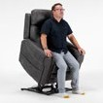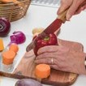Finalists for Best New Product Award are:

Vote now!
To vote, visit www.atsa.org.au/voting/
best-new-product-2023/
Voting closes 4pm AWST 31 May 2023.

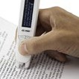
C-Pen Reader 2
Scanning Pens Stand, Perth
The C-Pen ReaderPen is used extensively
in schools and by healthcare professionals across Australia. The smart pen scans printed text and converts the text to speech, reading the words out to the user. The pens are useful in three main areas:
- For those with reading diﬃculties such as dyslexia, autism, ADHD, processing issues etc
- For those with a low reading or literacy level or
- For EAL students whose ﬁrst language is not English
The pens encourage reluctant readers to read and can boost
self-conﬁdence and reduce stress & reading anxiety.

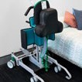
Kera Sit2sit Hoist
Aidacare Stand, Melbourne & Perth
The Kera sit2sit is a revolutionary new
type of hoist that empowers a single caregiver to be able to transfer a person, who has no standing strength or ability to hold on, quickly and safely between seated positions. It is providing a safer alternative to a sit-to-stand hoist and can delay the progression to using a sling hoist.
These outcomes have had life- changing eﬀects for clients, allowing them to stay in their own homes, save time and energy and reduce the risk of injury in their day-to-day transfers.

VOTE NOW!
Donatello Plus Lift Recliner (Alivio)
K Care Stand, Melbourne & Perth
The Donatello Plus Lift Recliner has been designed for home use and to improve the lives of people that may have mobility, postural support, pressure distribution, and general pain and discomfort issues.
The Donatello Plus is packed with features, including: Zero Gravity (tilt in space); Shiatsu Massage; Heated Seat; Lift and Tilt; Postural supports; Soft touch controller; Wireless Phone Charger; Drinks holder and Airline Style Head Support.

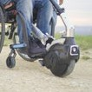
Klaxon Twist Power Assist
APEX Mobility Stand, Melbourne & Perth
A game-changer,
the Klaxon Twist, is an innovative power-assist device for manual wheelchairs.
Due to its unique, compact design, the Twist can be mounted out the front of the wheelchair,
or underneath, to give drive from the rear.
Twist is the compact, multi-function propulsion system that you need: a small wheel with an electric motor and a battery. Lightweight and manoeuvrable, Twist is designed to accompany you on every journey.
KandoKutter Safe Knife
KiddiKutter Stand, Perth
Adult Safe Knife. Cut, chop and slice safely with KandoKutter
Finally! The world’s ﬁrst adult safe knife is available. Designed for adults and teens with special needs to make prepping food easier and more enjoyable.
Features rounded serrations that eﬀectively cut through food, not skin. The unique patented blade works using a sawing motion that maintains contact with the food’s surface, taking away the risk of cuts. Made from a high-
quality stainless-steel blade that’s designed to last for years, with an attractive wood handle that’s easy to hold, KandoKutter enhances independence and self-conﬁdence.

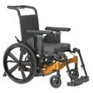
PDG Fuze Take-Apart Tilt-in-Space Wheelchair
Linds Rehabilitation, Melbourne & Perth
Take-Apart is an
optional frame upgrade that allows the wheelchair to be taken apart for easy transportation or storage.
Disassembly and reassembly take seconds and is completely tool-free. This feature reduces the weight of the heaviest piece of the wheelchair to 13kg or less. Independent power wheelchair users can consider adding power assist wheels to
this manual option, providing a transportable, powered tilting option with a total weight under 100kgs. The Fuze Take-Apart is perfect for transporting in the boot of a car or SUV. This take-apart tilt system puts travelling in an airplane back on the travel itinerary.

www.atsa.org.au/voting/best-new-product-2023/

Page 3

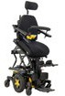
Quantum TB4
Pride Mobility Products Australia, Melbourne and Perth
The TRU-Balance® 4 Power Positioning Seating System has been designed
to truly meet the needs of users.
In addition to a full complement of stand power positioning functions, including power tilt, power recline, iLevel and power AFP, the TRU- Balance® 4 Power Positioning system provides 0 –30 degrees of power anterior tilt. TRU-Balance® 4 provides users with optimal access to perform activities of daily living. In addition, the dual
actuator Articulating Foot Platform (AFP) can be lowered to the ground to assist with transfers.
Therefore, allowing users the ability to maintain their independence
at home and in the community to retain autonomy in their lives without the additional need for support staﬀ.
To further complement the new TB4 seating system, an easily programable memory seating function is included to provide optimum seating needs throughout the day.
SIMO
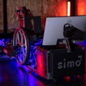
Motum Stand, Perth
The SIMO is an innovative mobility simulator that has
been designed to measure, validate and improve the sitting posture when scripting a manual wheelchair. It gives the user
an opportunity to compare and contrast minor tweaks to
positioning, facilitating a perfect ﬁt and providing the potential to try before you buy on what would have previously been a completely custom chair.
By simulating a virtual city environment, users are able to test their wheelchair and its performance.
There is in-built potential to automatically adjust: Seat width; Seat depth; Seat height (front and rear); Tilt; Backrest height and angle; Footrest height (front and rear); Overall frame length; Centre of gravity
The SIMO then measures each hand propulsion assessing the eﬀectiveness of each wheel spin – this enables identiﬁcation of the
optimal sitting position to achieve more speed, more power and ultimately, more freedom.
Scout Mobility Warrior Powered Hockey Wheelchair
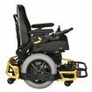
Wild West Wheelchairs Stand, Perth
The Scout Mobility Warrior is the ﬁrst Powered Hockey Sports Wheelchair on the Australian
market. The custom built Warrior Sport Wheelchair is designed
for indoor sport use only. It is a high performance wheelchair and requires suﬃcient physical and cognitive capabilities from the user. The Warrior has a top speed of 15km/h, handcrafted safety features, and modular adaptable features for every ability.
The Warrior is able to be controlled by a joystick, head array, breath tube, and numerous other ways.
Athletes with limited mobility are able to play without a hockey stick, instead using a “”T-Bar”” or “”T-Stick”” to control the ball with their chairs. Seat width and depth, and backrest width and height, are easily adjusted, as well as seat height, backrest angle, footplate height and angle, and guard depth. This makes a single Warrior chair able to be used by multiple athletes.

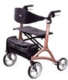
VivaPlus Seat Walker
Unicare Health Stand, Perth
A stylish plus-size
walker with an emphasis on style.
The Viva Seat Walker by Unicare oﬀers a patented depth-adjustable backrest, push button height adjustable handles, a wide padded seat, and a shiny metallic ﬁnish. The Viva is available in Rose Gold for
a touch of class and Meteor gray for a glaze of sophisticated luxury. It is the most feature-packed, reﬁned rollator Unicare has ever produced. These unique features and more, have made the Viva a game-changer and trendsetter in the mobility aid market.
With an emphasis on style, the VivaPlus is set to lead a new generation of mobility aids for our plus-size population that balances clinical characteristics with modern lifestyle features.

VOTE NOW!
Wonderseat by Spex
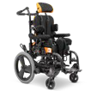
Medifab Stand, Melbourne & Perth
Wonderseat is more
than just a paediatric seating system. It’s a window to a world of fresh and exciting opportunities;
a symbol of fun, a promise of adventure and a vehicle for personal expression and empowerment.
Putting the fun into function.
The Wonderseat family consists of a range of paediatric wheelchair seating systems created speciﬁcally to provide children with the ultimate support.
From packaging to product ﬁnishings, Wonderseat is as uplifting as it is supportive!
Ziggy by Luddi
Luddi Stand, Melbourne & Perth
Invented by Luddi, the Ziggy boasts an array
of unique features that make it the most accessible and inclusive sexual wellness device ever created.
Designed with vision impairments in mind, the Ziggy features high- contrast colors and braille, making it easy to use for those with limited vision. Its unique shape and design have been crafted with wheelchair users and individuals with low- functioning upper limb/hand use or single-hand use in mind, allowing for eﬀortless use and maximum comfort.
With a long battery life of up to 3 months and magnetic features that facilitate easy wireless charging, the Ziggy product provides a versatile range of uses for both individuals who possess a penis and those who do not. Able-bodied individuals
will also love the user-friendly features, making the Ziggy the perfect solution for anyone seeking uncomplicated sexual wellness.

www.atsa.org.au/voting/best-new-product-2023/

Page 4

SUNRISE MEDICAL – CELEBRATING 40 YEARS!

For 40 years, Sunrise Medical has provided our customers the best possible assistive mobility solutions through absolute focus on individual needs, relentless pursuit of excellence, and great passion for innovations.

Our mission is to improve the lives of those with mobility challenges, to enable and encourage them to live their lives to the fullest without limits! Sunrise Medical has one of the broadest and most innovative product portfolios in the industry, under our own 17 strong proprietary brands. We are proud
to accomplish this with more than 2600 committed Sunrise Medical associates in 19 countries, together with our families, friends and our equally passionate and driven business partners and clinicians in over 130 countries, to whom we’re immensely grateful.

As we celebrate this remarkable milestone of our 40th anniversary, we are reminded of the Thomas Edison quote, “Vision without execution is just hallucination”. And as our group CEO, Thomas Babacan always says “As long as better is possible, good is not good enough”. At Sunrise Medical, we will continue our great journey, together with you, striving to improve people’s lives. Not only can we envision a better future, but we bring it to reality through our absolute commitment to excellence and dedication to the customers we serve.
Errol Hyde - Early distributor for Quickie / Sunrise Medical
“It’s a lifetime ago since Sonja and I registered our little business and became wheelchair
suppliers, working initially with two very good local manufacturers before joining Sunrise Medical.

I travelled throughout Sydney, to Newcastle, the Blue Mountains and Wollongong, to Hospitals, Rehab Centres, Community groups and to many, many homes.

The Quickie 2 with the ‘free growth kit’, was fun to work with, and a real joy as kids quickly adapted from stroller to chair - My favourite product.

So, whilst running a busy little business, I also trained, travelled and played basketball, competed in tennis; throughout Australia and for Australia around the world.

The variety of everyday chairs, cushions, backrests plus incredible sports equipment has really evolved over that time, and Australian wheelchair users have access to the worlds very best.”

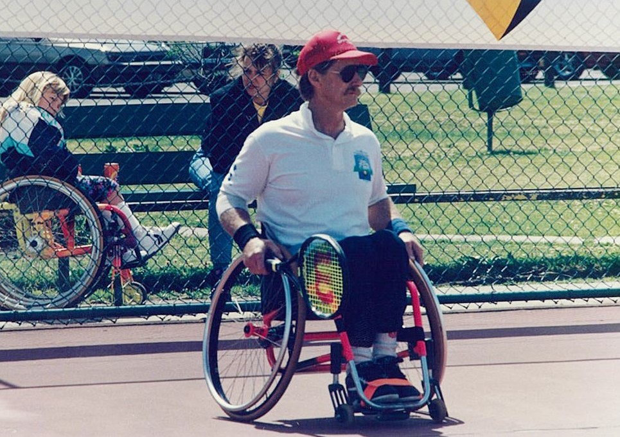

Errol Hyde - Early distributor for Quickie / Sunrise Medical

Page 5

GTK FORMALLY OPEN NEW SITE IN BRISBANE

GTK are delighted to announce the opening of their new Brisbane office. With offices already in Sydney,
Melbourne, Newcastle and Ballina, the addition of the Brisbane office allows GTK to support clients, families and clinicians in the South-East Queensland area.

GTK Brisbane is staffed by a team of experienced professionals who are dedicated to providing the best possible service to clients and families. The team is excited to begin working with clinicians, families, and clients in the area to help them find the right assistive technology solutions to meet their needs.
The GTK Brisbane team is led by Nick Mavroudis, who has come to GTK with over 18 years of experience working within the assistive technology field. He is joined by Kevin Cosier with over six years’ experience in scripting AT solutions and Mellinda Fitzgerald (Physiotherapist), who’s career spans over 22 years, working mostly in paediatric settings.

To officially open their new Brisbane site, GTK hosted an Open Day in April which was filled with lots of learning, interactive activities and fun-filled moments. The GTK Team would like to thank their manufacturer partners for their assistance with the Open Day.

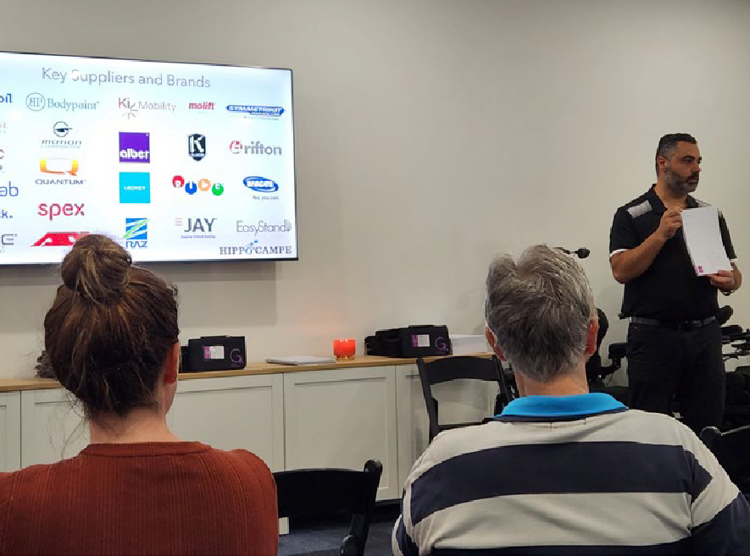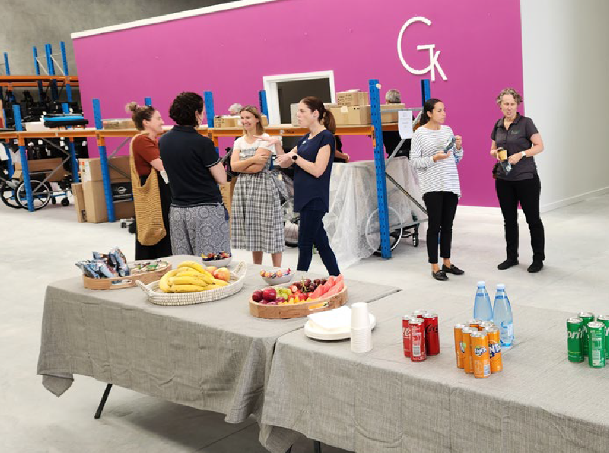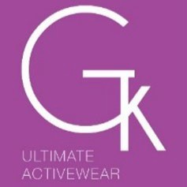

Page 6

Sunday 8 – Tuesday 10
October 2023

RACV Royal Pines Resort, Gold Coast Queensland

Featuring...
Join us at Leading with Vision, the ADIA Leadership Conference brought to you in partnership with ATSA, and take your business to new heights! Held on the beautiful Gold Coast, Leading with Vision is your opportunity to be
inspired by fresh insights and network with industry leaders.

Entrepreneur and best-selling author,
Mark Bouris AM

Triple Olympian, Lisa Curry AO

Former Olympic gymnast, Brennon Dowrick

The Sales Dr, Ingrid Maynard

The People Whisperer, Anneli Blundell

...and many more still to be announced, this is an event not to be missed.

ATSA MEMBERS
Bring your whole team and get exclusive member-only discounts on registration fees!
Registrations open now!
Book early to take advantage of the early bird
and multi-ticket discounts.

Page 7

NATIONAL CABINET COMMITS TO A SUSTAINABLE NDIS

The Hon Bill Shorten MP recently delivered an address at the National Press Club and issued a press release, to state the “National Cabinet has committed to efforts to reboot the National Disability Insurance Scheme”.

Once you cut through the political messages what does this mean?

The simple answer is the NDIS is to stay, and the principles have not changed and there is a real intent to ensure that the investment delivers for not just the participant of the NDIS but the taxpayer.

This is backed up by the NDIS Financial Sustainability Framework agreed by National Cabinet as it will provide an annual growth target for the total costs of the Scheme of 8 per cent by 1 July 2026, with further moderation of growth as the Scheme matures.

Even before the change in government there has been work underway to address operational
issues of the scheme. This included changes to the legislation to improve processes and procedures including the investment into a new IT system to allow for data to be gathered, with the intent to allow for better management of participants plans that are now just starting to be rolled out.

The statement made by Minister Shorten has framed the approach of the new government as

“These reforms are about ensuring the future of the Scheme in the best interests of the participants and our reboot is making sure every dollar gets through to the people the Scheme was designed for, NDIS participants with severe and permanent disabilities.”

More than $720 million over four years from 2023-24 in this year’s Budget to lift the NDIA’s
capability, capacity and systems to better support participants is to be set aside. ATSA cannot comment if this is above the investment that was
provided to replace the original operating systems by the previous government or a restatement
of investment. Regardless, it is a positive sign that investment is been made to improve the infrastructure of the NDIS and will provide data that will aid in the management of the scheme.

This investment includes 10 key initiatives:
- Investing in better decision-making processes and planner capability for participants with specialised needs.
- Moving to less frequent plan reviews where it makes sense and committing to participants that not spending budgets won’t affect future plans.
- Improving lifetime planning approach to ensure plans are more transparent and flexible for
life events. This includes the flexibility where participants do not need as much support at a stage of life but know that they can receive support as their circumstances change.
- Better supporting participants to manage their plan within budget, including assistance from NDIA during the year and holding plan managers, support coordinators and providers to account.
- Partnering with communities to pilot alternative commissioning to improve access to supports in remote and First Nations communities.
- Working with participants and providers to trial blended payments to increase incentives for providers to innovate service delivery and achieve outcomes for participants
and governments.

Page 8

- Establishing an expert advisory panel to list items to make it easier for participants to access proven evidence-based assistive technology and other supports.
- Implementing preferred provider arrangements to leverage buying power of the NDIS.
- Strengthening guidelines for planners on support volumes and intensity and providing clear minimum standards of evidence for assistance with daily living.
- Cracking down on fraud and non-compliance by funding, in addition to the Fraud Fusion Taskforce, 200 staff for two years and developing a business case for a new system to detect, prevent and reduce non-compliant payments.
You will note the highlighted points, of 4,6,7 and 8 in the NDIS Financial Sustainability Framework will likely have implications to businesses who supply AT. ATSA does not know any of the details that sit behind these points but will monitor.

However, point 4 comes as no surprise as, the government has raised its concerns with ATSA on several occasions re cost of the supply of AT, under both Liberal and Labour governments. There is a belief that there is little to no industry competition in the market when it comes to the supply of AT. This accusation was also raised by Minister Shorten during Q&A on the 24 November 2022, that our industry is running a cartel. I suggest that this statement was aimed to sensationalise the matter and we have endeavoured to seek clarification from Minister Shorten, to date without success.

Regardless, issues around over pricing, price collusion is a very serious matter. One area that has been put to ATSA, is the charging NDIS clients the

maximum amount allowable under the NDIS, and when the customer shops around, they find pricing with in $30 on product that is valued over $5000.

This circumstance creates the perception of non- competitive behaviour that raises the question of possible collusion including price gouging behaviour, even if it is not true. It is important to remember that the NDIS is a consumer-based purchasing model, and market offerings should
have differences in pricing and service offerings. It is a simple fact that competitor businesses should have differences in their business models including their market offering, the delivery of service that result in price differentiation greater than $30 on a quote for high value items. Therefore, based on what has been put to ATSA, and can see why Minister Shorten has drawn this conclusion, and why point 4 is in the plan.

As an industry we do not want a situation where the behaviour of a few results in a change in policy that impacts all suppliers. ATSA continues to defend the industry and seeks opportunities to work with the government to overcome these perceptions.

It is important to note, that the early signalling by the new government of their objectives provides insights of the future direction and allows for you to consider opportunities to shape your business to the direction of the Albanese Government for the NDIS.

Page 9

HOME CARE PACKAGES

The Department of Health and Aged Care have adopted a reablement approach with their Home Care and CHSP services. This includes time- limited inventions to help a care recipient adapt to functional loss or regaining confidence so they can reach their goals and maximise independence and autonomy. In regard to Assistive Technology (AT) this could mean looking at what else might help (for example, support to go out, personal alarms, home modifications or other equipment, such as bath rails) and equipment and technology to help a care recipient live more independently at home.
Recommendations for aids and equipment, care and services may be funded under the HCP, provided they meet the other requirements of the inclusions and exclusions framework. See Home Care Packages Program Inclusions and Exclusions – FAQs for Providers – version 1 (health.gov.au)

Health professionals operating within their scope of practice may assess for GEAT and are advised to consult the Department of Veterans’ Affairs Rehabilitation Appliances Program at https://www.dva.gov.au/sites/default/files/2022-03/ rap-schedule-march-2022.pdf (for reference purposes only - not all equipment covered by
DVA is available under HCP).
For care recipients on Level one to four package or awaiting their package with an urgent need, but insufficient funds in their package budget for
goods, equipment and assistive technology (GEAT), they may access GEAT in the short term. These instances should be time limited, monitored and reviewed. During these times, the package is not suspended; both the HCP Program and the CHSP will be received concurrently.

If you have any questions in regard to AT,
please contact the Home Care operations team: hcoperations@health.gov.au

Home Care Packages Program Inclusions and Exclusions – FAQs for Providers – version 1 (health.gov.au)

Page 10

ATSA IS BRING YOU MORE BUSINESS EDUCATION TO FOCUS ON YOUR TEAM, MENTAL HEALTH, SALES AND MORE.

How to be an Inclusive Leader in 2023 – with Dr Lisa Mayocchi
Virtual Workshop Thursday 22nd June 2023 11:00 am AEST
Click here to register
Being a supportive inclusive leader makes business sense. Teams who work in an inclusive climate perform
better, have higher job satisfaction
and improved wellbeing. They also show higher levels of organisational commitment.
As we move through 2023, many workplaces are focused on ways to rebuild the resilience and energy levels of their teams, as they adapt to a ‘new normal’ post COVID-19, and continue to lead their teams through uncertainty and change. When it comes to leadership, the trend is definitely moving away from ‘toughness’ to ‘supportive’, ‘inclusive’ and ‘compassionate’.
In this webinar, Lisa Mayocchi and Kash Thomson will share some practical tips and strategies on how to be a supportive, inclusive leader while navigating current challenges. The session will provide insights on:
- What it means to be a supportive and inclusive leader, and why it matters – the latest evidence
- Key foundations for leaders
- What it means in practice – hints and tips
- How to be an inclusive leader in a hybrid and remote working environment, and when leading through change

Speaker: Dr Lisa Mayocchi
Lisa is registered psychologist with a Doctorate in Organisational Psychology, and over 20 years experience working in leadership, wellbeing
and change. She is passionate about helping organisations, teams and individuals to become more effective, more confident and more impactful.

Lisa has worked in Australia and the UK with a variety of public and private sector organisations to support resilience and wellbeing, inclusion, leadership and high-performance cultures.
She particularly enjoys one-to-one coaching, facilitating team events and leading leadership programs, whether that’s bite-sized training, residential or multi-day programs. She loves creating bespoke programs for her clients and sharing practical, evidence-based techniques that work in practice.

Lisa developed her interest in inclusive leadership while working at the Bank of England, where she played a key role in a range of inclusion initiatives. This included training managers on how to be inclusive and supportive leaders; supporting business areas to develop Inclusion Plans; and driving the rollout of the Bank’s first Inclusion Fortnight – a series of events and activities that focused on inclusion, diversity and wellbeing.
Since returning to Australia, Lisa’s work has been focused on culture change and employee engagement, resilience and wellbeing,
and helping organisations to create high performance cultures.

Questions?
Please email events@atsa.org.au
If there is a business topic or education session you would like to see in the 2023 calendar please let us know.

Page 11

10 Common workplace relations pitfalls for SMEs (and how to avoid them)
Virtual Workshop Wednesday, 26 July 2023
10-11:00 am AEST
Click here to register
ATSA has teamed up with Employsure to bring you this specially designed webinar exclusively for ATSA members.

At Employsure, we have spoken with thousands of SMEs and their practices over the last 10+ years, and several trends and patterns have emerged as a result.

This webinar will discuss 10 of our most common workplace relations pitfalls we come across, that many SME business owners make, and often without realising.

Learn how best to safeguard your business regarding your legal obligations to the Fair Work & Safe Work regulators.

Questions?
Please email events@atsa.org.au
If there is a business topic or education session you would like to see in the 2023 calendar please let us know.

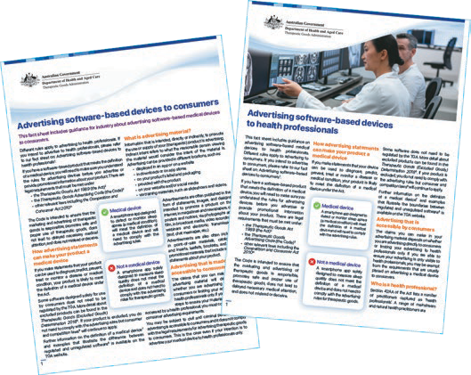
TGA CONTINUES TO IMPLEMENT REFORMS TO THE REGULATION OF SOFTWARE BASED MEDICAL DEVICES

The TGA has recently published the following two factsheets to provide information for industry regarding the advertising of software based medical devices to health professionals and consumers.

- Factsheet – Advertising software based medical devices to health professionals (pdf,289kb)
- Factsheet – Advertising software based medical devices to consumers (pdf,291kb)
For further information on the regulation of software based medical devices, please see all guidance on the topic published on the TGA website.

Page 12

DEVELOPING A BUSINESS STRATEGY IS ONE THING, BUT IMPLEMENTING IT IS ANOTHER
BY JOSHNA DAYA AND GREG GUNTHER | YOUR BUSINESS MOMENTUM

As the end of the financial year (EOFY) approaches, it’s a good time to start thinking about your business’s strategy planning for the coming year.
Whether you’re a small business owner or a larger enterprise, strategy planning is an essential part of ensuring that your business is well-positioned for success. However, many entrepreneurs overlook the importance of strategic planning, which can hinder their ability to achieve long-term goals.

A strategic plan goes beyond just setting goals; it details the necessary steps that must be taken to achieve them. In spite of well-crafted strategies, if they are not implemented properly, they will fail to yield the desired results.

Why Strategy Planning is Important Before EOFY
Strategy planning is critical for any business, and it’s especially important before EOFY. By taking the time to review your business’s performance over the past year, you can identify any areas where you need to improve and develop a plan to achieve your goals for the coming year.
Businesses of all sizes and stages need a strategic plan. It allows a business to maximise its resources, identify new opportunities, and increase
profitability. Regardless of whether you are starting a new business or growing an existing one, it is vital to develop an effective strategic plan that aligns with your purpose and long-term goals.

The Importance of Relentless Implementation
While strategy planning is important, it’s not enough to simply develop a plan and hope for the best. The key to achieving your goals is relentless implementation. This means staying focused on your plan, taking action, and making adjustments as needed to ensure that you’re making progress toward your goals.

It takes more than a vision to succeed with a business strategy. Your
vision must be quantifiable and anchored by clear, measurable goals,

Page 13

milestones, and benchmarks that serve as stepping stones towards achieving your ultimate objective.
By establishing this foundational step, you’ll have a roadmap that will help you make informed decisions, measure progress, and stay focused on achieving your objectives. Each step you take will bring you closer to your ultimate goal, giving you the confidence to move forward with your strategy.

Finally, being flexible and adaptable is a critical component of executing a successful strategy. As the business landscape continues to evolve, it’s important to remain vigilant and prepared to make the necessary adjustments to stay on
track to achieving your long-term goals. Regularly monitoring your progress, evaluating your results, and making the necessary tweaks to your strategy will help you stay ahead of the curve and maximise your chances of success. Remember that a willingness to adapt is key to staying competitive in today’s ever-changing business environment.
Our view is that strategy should be a live, breathing document and consistently revisited.

No matter how well thought out a strategy is, it will fail without proper execution. The implementation should be done with a sense of urgency and should involve clear communication and accountability with all team members to ensure everyone is on the same page.

Strategy planning before EOFY is an essential task for any business. By developing a detailed action plan, assigning responsibility, monitoring progress, making adjustments, and staying focused, you can implement your strategy relentlessly and achieve your goals. Remember, it’s not enough to simply develop a plan – you need to take action and stay committed to achieving your goals to succeed.

Are you ready to take your business to the next level and take a look at your business with a fresh set of eyes?
Don’t overlook the importance of strategic planning. If you are a well-established business, get in touch with us by booking a complimentary call.
Let’s work together to develop a sound business strategy, and we’ll work with you in implementing it effectively for your long-term success!
You can book a call by clicking here.

Page 14

Common HR & WHS Pitfalls for SME’s

SME business owners often find themselves in a pile of tasks that keep growing and they often need to perform different and contrasting roles (some outside their skillset) in order to complete them. In the midst of all this, there are certain things that slip through the cracks.

Employsure has carefully studied and spoke with thousands of small to medium business owners over the last 10+ years and several trends have emerged.

Many of them:

- Don’t have qualified & tailored HR and WHS support, unlike most larger businesses
- Have the best intentions, but they don’t know what they don’t know, which leaves them exposed (often without realising it)
- Don’t know how to correctly manage HR issues like performance, conduct, discipline,
terminations, redundancies, requests for flexible working arrangements, casual conversion, etc.
- Fail to “properly” formalise employment contracts for all their staff and keep them up to date where required
- Struggle with our complex & ever-changing Modern Awards
- Don’t keep up with ongoing legislative changes by Fair Work and Safe Work
- Fail to keep up with employment record keeping requirements
- Neglect to build policies & procedures in place
- Don’t fully understand their legal Health & Safety obligations (especially with mental health & psychosocial hazards)
- Mistakenly think that their workers compensation insurance alone will cover them in a notifiable workplace incident.

- Not realise that their primary duty of care for Health & Safety extends to ALL of their workers which includes contractors, sub-contractors, volunteers, work experience students & labour hire. (As well as anyone entering the business premises such as customers, friends & family, delivery people, utility workers)
- Try and do everything themselves (and neglect the benefits of outsourcing to experts)
- Think that they don’t need to worry about any of the above because they are “only a small business”.
If any of the above sounds familiar to you,
then please reach out to Brett Winduss for a FREE, confidential & obligation-free discussion around getting your HR & WHS foundations sorted to safeguard your business (and your workers).

It is always best to be proactive (not reactive) with regard to your Fair Work and Safe Work obligations.

At Employsure, they advise, support and protect over 30,000 businesses across Australia & NZ with the above. They can support your business too.

Kind Regards

Brett Winduss
BRETT WINDUSS
Employsure
Ph: 0418 935 057
Email: brett.winduss@employsure.com.au
Page 15

Australia’s foremost assistive technology event
CANBERRA
7-8 NOV 2023
EXHIBITION PARK (EPIC)
BY THE INDUSTRY FOR THE INDUSTRY

REGISTER
NOW

ADELAIDE

6-7 MARCH 2024
ADELAIDE SHOWGROUND

SYDNEY

22-23 MAY 2024
SYDNEY SHOWGROUND

BRISBANE

29-30 MAY 2024
BRISBANE CONVENTION & EXHIBITION CENTRE

1300 789 845
www.atsaindependentlivingexpo.com.au

Organised by Media Partners

