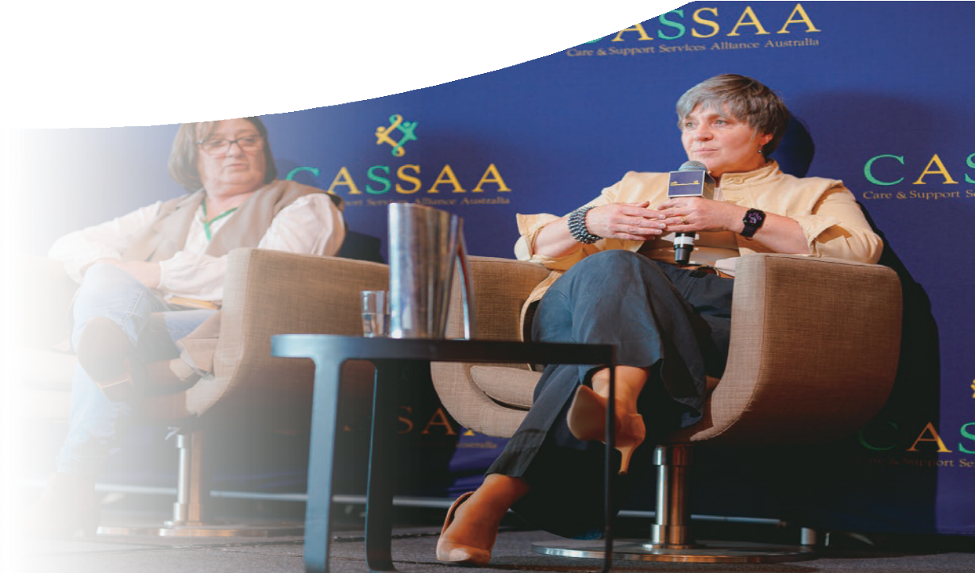

NOVEMBER 2023
www.atsa.org.au

CEO Welcome
ATSA Newsletter
Serena Ovens
CEO, ATSA
Welcome, I can’t believe it’s been over three months since I assumed my role at ATSA, and what an eventful period it has been!
In addition to familiarising myself with the team and board, I’ve had the opportunity to conduct member visits whenever possible, which has been truly rewarding. One notable event during this time was my participation as a speaker at the NDIS Communities conference in Melbourne in early August, where I had the privilege of addressing over 500 attendees. My goal was to raise awareness of the importance of collaborating with ATSA members when
procuring assistive technology (AT) and home modifications. I was also able to emphasise the invaluable expertise that our industry brings to the table and ensure those in the room knew to reach out to ATSA members for their expertise and assistance in and AT procurement process.
I extend my sincere gratitude to the dedicated teams at Pride Mobility, Automobility and Independence Automotive in Victoria for graciously introducing me to their businesses and providing me with insights into the intricacies of their operations during my visits.
In early September, I journeyed to Canberra to attend my first Therapeutic Goods Association (TGA)
Reg Tech meeting. This marked the beginning of my endeavours to understand the complexities of the regulatory process for certifying many of the devices that our members import and sell.
This may take some time to master fully!! While in Canberra, I also took the opportunity to introduce myself to Cliff at Southern Electric Scooters. I benefited greatly from his extensive knowledge of the AT industry, which has witnessed substantial changes
over the years. Cliff mentioned his frustration with the unwieldy audit principles that hold little relevance to AT providers during his re-accreditation
process for the NDIS. This is a recurring concern I’ve encountered in my brief tenure, and I plan to engage with the NDIS Quality

ATSA
Board Members
Chair
Nikolas Witcombe (Total Ability)
Vice Chair
Philippa Bell (Board Appointed)
Financial Director
Andrew Webster (Country Care Group)
Directors
Amin Akbarian (Mobility Engineering) Matthew Butterworth (Magic Mobility)
Michael Linke (Vision Australia, Board Appointed) Jacinta Maurin (Sunrise Medical)
Stewart McDonagh (Independent Living Specialists) Jeff Watters (Automobility)
Page 1

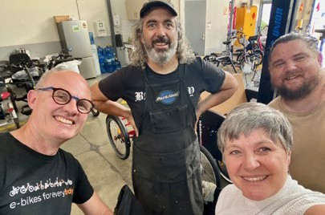
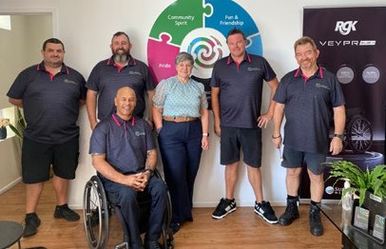
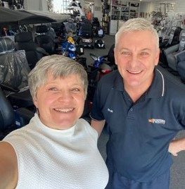
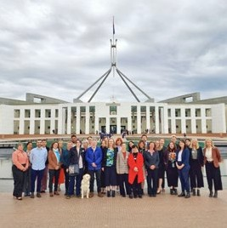
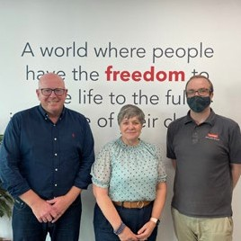
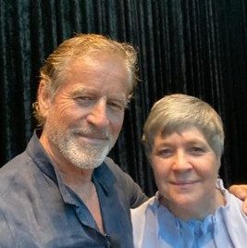
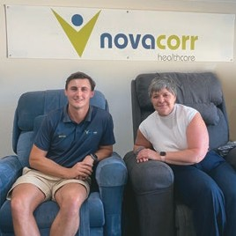
CEO WELCOME

Continued...

and Safeguards Commission to explore reasonable adjustments that can ease the burden on both auditors and the industry, aligning the process more closely with the work our members do.
I had the privilege of spending time at Parliament House, participating in a two-day government relations masterclass. This allowed me to advocate for ATSA’s concerns and interests with a wide array of parliamentary members and advisors. I hope this marks the beginning of building relationships with
individuals who can help us advance inclusive change and support best practice in equitable AT provision for all Australians, regardless of the scheme they may fall under.
Our collaboration with the Australian Dental Industry Association (ADIA) on their Leading with Vision conference didn’t quite meet the attendance expectations we had set. Nevertheless, for those who made the journey to the Gold Coast, we were treated to exceptional speakers who provided invaluable insights. In a world where Artificial Intelligence is becoming increasingly relevant and cyber risks are on the rise, our roles in the AT industry are growing more complex. It was inspiring to have visionaries like Todd Sampson, Mark Bouris, ANZ economic analysts, and others share innovative ideas that could help us navigate these challenges.
While in Queensland, I once again had the pleasure of visiting our members. I am deeply appreciative of those who took the time out of their busy schedules to share their insights on how ATSA can be of greater assistance to them. Special thanks go out to industry legend Ian Rothall, as well as the teams at Tunstall Health, Wicked Wheelchairs, Suncoast Scooters and Mobility, Novacorr and Everybody eBikes.
Looking ahead, I’ll be attending Peak Care Group’s conference at the end of October to provide an ATSA update. I will deliver an industry update at ATSA Independent Living Expo in Canberra where we’ll also have some Melbourne Cup day festivities. In late November, I’ll be traveling to Perth to attend the Accessibility Awards and conduct more member visits. If I don’t manage to set up a meeting with you, please don’t hesitate to catch up with me at any of these events or during the ATSA AGM on November 29, either in person in Parramatta or online.
In breaking news, we’ve secured the Honorable Victor Dominello as our keynote speaker for the AGM. I’m looking forward to his insights into digital innovation and accessibility (and life after Parliament!) Please put the date in your diaries and come and join us to celebrate another year of incredible work with refreshments provided after the formal proceedings.
The team have also been hard at work – read on to find out more!

Serena

Important dates In this issue

Page

2023

ATSA Independent Living Expo, Canberra
8 – 9 November 2023

OSS - Melbourne
21-23 November 2023

ATSA AGM, Sydney
29 November 2023

ATSA Christmas Closing Dates
Our office is closed from 23 December & we are back on 2 January 2024

2024

ATSA Independent Living Expo, Adelaide
6 – 7 March 2024

ATSA Independent Living Expo, Sydney
22 – 23 May 2024

ATSA Independent Living Expo, Brisbane
29 – 30 May 2024

ATSA Awards Dinner, Brisbane
29 May 2024

Rehacare – Dusseldorf, Germany
25-28 September 2024

Home Care & Rehabilitation Exhibition 2024 – Tokyo, Japan
2-4 October 2024
ATSA News 1
Important Dates 3
What ATSA members have been up to 4
Information to boost AT decision confidence 8
Industry Updates 10
Industry Event – Oceania Seating Symposium 11
Business Education 12
Oracle Group Insurance 14

Phone: (02) 8006 7357
Mail: PO Box 562, Ryde NSW 1680
Email: info@atsa.org.au Website: www.atsa.org.au
ABN: 58 628 080 517

Page 3

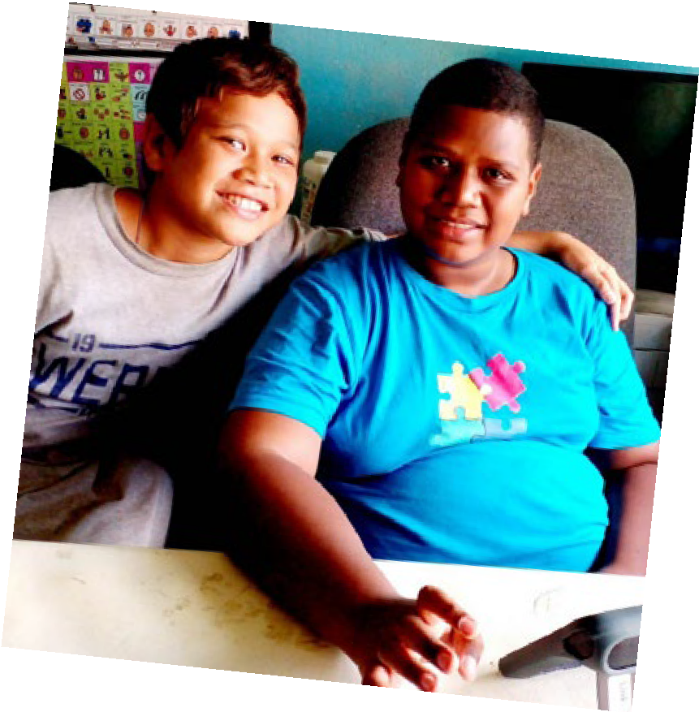
Bridge Assistive is a not-for-profit company that aims to increase the use of high-tech assistive communication devices in developing countries. Bridge Assistive is a subsidiary of Link Assistive and officially registered as a charity organisation with the Australian Charities and Not-for-profits Commission (ACN: 661 392 169).

Sustainable v implementation projects
Bridge Assistive aims to implement sustainable AAC projects in developing countries. They are currently working to set up projects in Ghana and Fiji. The projects will be evaluated, to improve approaches over time and add to the body of evidence.
Bridge Assistive has received full ethics approval for their first project in Ghana that is expected to start in October. The project is a collaboration between Bridge Assistive, Curtin University, and the University of Ghana and will include the training of seven Ghanaian Speech Language Therapists (SLTs). The SLTs will undergo an online AAC training course and will each receive an AAC kit, so they can build up hands-on experience with AAC devices. After completion of the online training, the SLTs will have three one-on- one mentoring sessions with Link Assistive’s Speech Pathologists. The SLTs will be asked to use their AAC kits for client assessments and can apply for individual AAC device donations using the Bridge Assistive Online Application System.
A Fijian project is in the developing phase and will include collaborations with the Frank Hilton Organisation and Charles Sturt University.

Apply for AAC
In addition to the formal projects, people from developing countries can apply for donation of a (second-hand) AAC device through Bridge
Assistive’s online application process. Applications from all developing countries are welcome and
can be submitted by speech pathologists, other health care providers, educators, and carers.
The applications will be reviewed by one of Link Assistive’s speech pathologists and approval will depend on: 1) meeting pre-set criteria; and 2) availability of devices and services. After approval, Bridge Assistive will prepare the device, ship it to
the applicant, and provide clinical and technical support. Bridge Assistive received the following feedback from the support team of their first young Fijian client during a follow-up clinical session:
‘Having the device has made his family and teachers understand him more’
‘He communicates things we would never have imagined’
‘He uses so many words’
‘The teachers are surprised at his academic level’
‘It has helped his frustration, he can now communicate his emotions’
‘It’s magical’

Donate a device
Bridge Assistive is looking for more second-hand communication devices including Tobii Dynavox devices, Attainment Go Talks, Ablenet Quicktalkers, Jelly Bean switches, Big Macks or Step by Steps, switch activated toys, or Rehadapt Table and/or Floor stands. Please consider donating any unused devices as listed above that are not older than
five years. Other devices may also be eligible for donation, so please contact Bridge Assistive for more information.

office@bridgeassistive.com www.bridgeassistive.com

Page 4

In a first event of its kind WeRide conducted a briefing for Parliamentarians and guests on the bikes that can give back mobility to those experiencing disability and a lack of choice in mobility.
In a breakfast event in Parliament in August, the Chairs of the Friends of Cycling group hosted their colleagues, guests and the Shadow Minister for the NDIS, the Hon. Michael Sukkar MP, for a presentation on the latest e-assist bikes and trikes that
provide people of all ages and abilities options for independent mobility, physical activity or simply fun.
Watch a short video of the event – 3 min.
Andrea Herklots from Everybody ebikes talked about the machines they provide to children and adults with a range of diverse needs and the transformational power of being able to cycle.
This includes children who can ride to school for the first time in their lives, adults who can use
an e-assist bike or trike to get to work and local destinations for the first time or simply being able to take their partner who has a disability or dementia out riding again.

The emotional stories show how modern cycling technology, including e-bikes, provides choice, improves accessibility and provides affordable pathways to overcome exclusion from mainstream transport options.
Watch Andrea’s address at the event (8min video).

Andrea Herklots, of EveryBody eBikes talks about the transformational nature of e-assist bikes and trikes that give mobility to young and old alike.

Above: The Parliamentary Friends of Cycling group welcomed their colleagues and guests to an event showcasing the latest machines that
give back mobility to those experiencing disability.

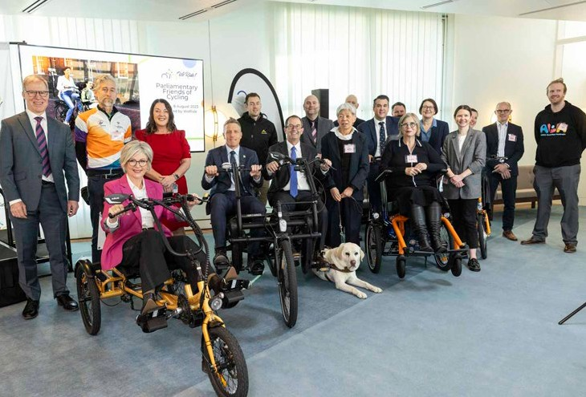
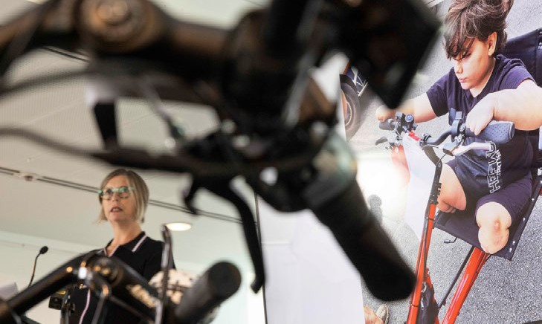

Page 5

We Ride Continued...

Justin Le Couteur, representing the National Inclusive Transport Advocacy Network, talked about the 4.4 million people with disability in Australia today, which is 18% of the population. Of all those who are of driving age, only about half actually drive and Justin emphasised the importance of equitable options for all those with a disability.
With a humorous take on the technology available to him growing up with cerebral palsy, he compared his (low tech) training wheels and devil-may-care attitude to the enormous opportunities available today. He discussed the institutional and infrastructure barriers that are beginning to be addressed by policy and programs such as the NDIS.
Watch Justin’s address at the event (4 min video).

In an update on EveryBody eBike...
They have received a Special Mention as finalist in the Small Business Award Category of the Lord Mayor’s Business Awards in Brisbane and Richard has been selected as a finalist in the Leadership category of the We Ride Australia Cycling Luminaries Awards for 2023. Congratulations and good luck!

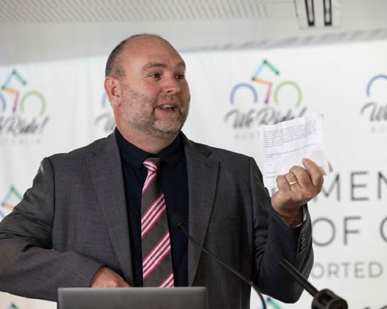

Above: Justin Le Couteur, representing the National Inclusive Transport Advocacy Network, gave the opening address talking about the transformational power of accessible mobility and the 4.4 million Australians who can benefit from access to some of the machines on display today.

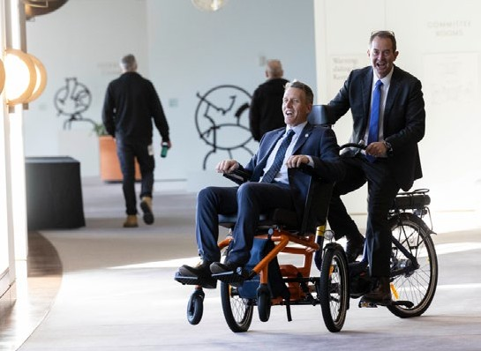
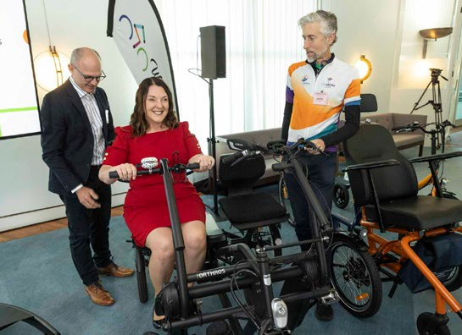
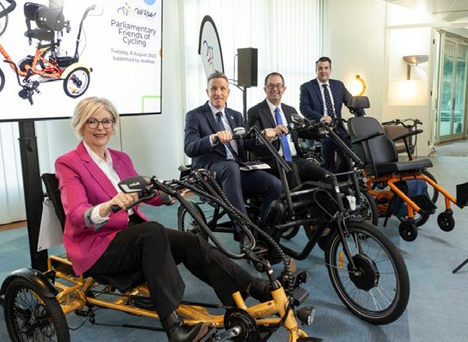
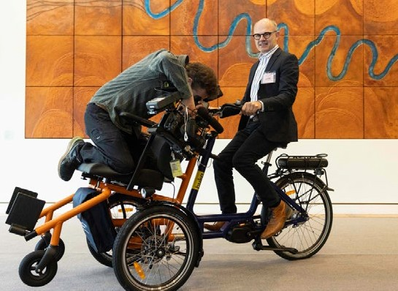

Page 6

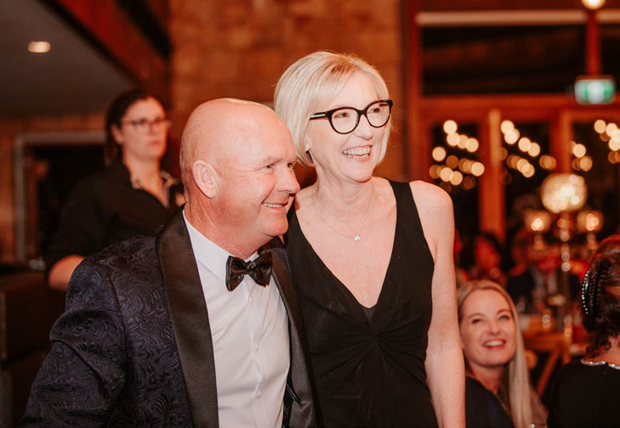
The Busselton Chamber of Commerce and Dunsborough Yallingup Chamber of Commerce are in their fifth year of hosting the Business Excellence Awards, which really gives small businesses an opportunity to reflect on the past year and consider what the next 12 months could look like.
winners in three categories:
- Excellence in Customer Service
- Small Business (11+ FTE)
- Outstanding Business of the Year
proud and grateful to have won the Outstanding Business of the Year Award”
Jo Mitchell, Managing Director, Cape Abilities.
Graham and Jo Mitchell
Page 7
It is an opportunity to come together with other local businesses and encourage, support and celebrate our business community in the South West, WA.
Amongst a record number of applicants, the esteemed panel of judges faced a challenging task, as the quality of applicants reached new heights.
“This year, the business community has confronted various challenges from skilled staff shortages,
to housing issues and policy changes. It is truly inspiring to witness how businesses have not only weathered these challenges but also displayed remarkable innovation and collaboration in overcoming them”. Victoria Yuen, Chief Executive Office, BCCI.

On 13th October, at an outstanding Gala Dinner, the winners were announced. Cape Abilities were

“We have a team at Cape Abilities, that every day, go out of their way to provide the best possible service they can to our clients. I say, without hesitation, that the individual team members are worthy receivers of the Excellence in Customer Service Award. I am thrilled for the team to
Winners!
have this acknowledgement from the business community. There were many great business represented at the awards and we are beyond

Informed Customers Boost AT Decision Confidence

Are you searching for innovative ways to increase your customer satisfaction and sales?
One of the apparent challenges of selling Assistive Technology (AT) is the sheer number of options available, and each customer’s needs and preferences are unique. It can be difficult to showcase all the features and benefits of your
products to assure customers that your product will meet their needs and is worth the investment.
Referring your customers to AT Chat may be a great way to boost your business. Our AT community can help your customers to have
confidence they are making an informed decision about an AT product and its suitability to meet their specific needs.
AT Chat is a peer-led, co-designed community for AT users who share information and lived experiences about AT. We deliver a peer-led information and mentoring service that provides our community with the opportunity to build their AT decision-making capability and share their expertise with each other and the broader community.
AT Chat’s range of services and supports, includes:
- AT Mentor Service: A service that provides one- on-one guidance and advice from a qualified AT Mentor who works alongside the customer to research and discover low risk, low to mid-cost AT that will help them pursue their goals. The AT Mentor also provides the necessary evidence and letters of recommendation to seek approval to purchase the AT through the NDIS.
- AT Portal: A free online hub where people can store all their AT information (including service schedules), and access our library of high- quality, accessible, relevant, and peer-led AT information videos, articles, and resources.
We also offer AT specific e-learning modules through AT Discover.
- AT Chatterbox: A private Facebook group that provides a safe space for AT users to ask questions, answer questions, encourage each other, and learn from the lived experiences of other people who use AT to live, play
and work. Members are supported to make informed decisions about
an AT solution that will meet their goals.

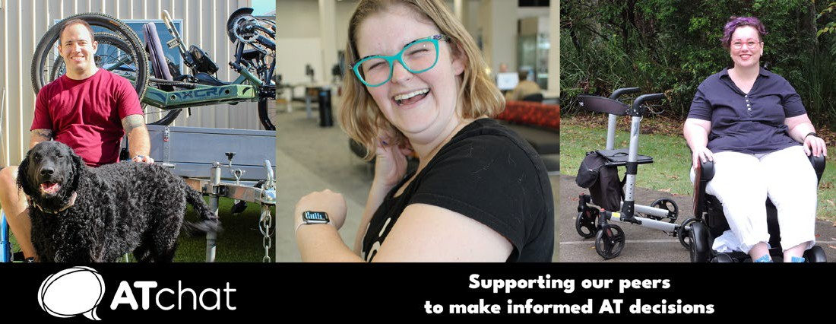

Page 8

AT Chat continued...

By referring your customers to AT Chat, you can help them benefit from the following:
- Peer support: Joining the AT Chat community gives customers access to an active community of over 1,400 people who are passionate about supporting their peers on their AT Journey.
- Capacity building: Connecting customers with their peers offers them the opportunity to
build their AT decision-making confidence and capabilities through receiving and sharing lived experience, knowledge, and access to peer-led information resources.
- Personalised guidance: Customers can access one-on-one support with a peer who is qualified to help them discover and make a decision about a product that will help them meet their goals.
Referring your customers to AT Chat can build trust in your customer base and help them feel confident that they are being supported to make a fully informed decision when purchasing your products.
As David Goodacre, Commercial Sales Manager from Daily Living Products, shared:
“When I’ve gone out on trials and I’ve been speaking to the clients, they’ve told me they have used AT Chat to find information about the product that they are trialling from other people that have
used it, and to find out what their experience was like. I find that it is a really helpful tool for people to be able to speak to others who have used the equipment as well, so it reassures them that it is the right product for them.”
You can refer your customers to AT Chat by directing them to the AT Chat website, or contacting us via email or phone (08) 6202 4728. You can also follow us on social media to stay informed about our latest articles and activities which you’re welcome to share with your networks.

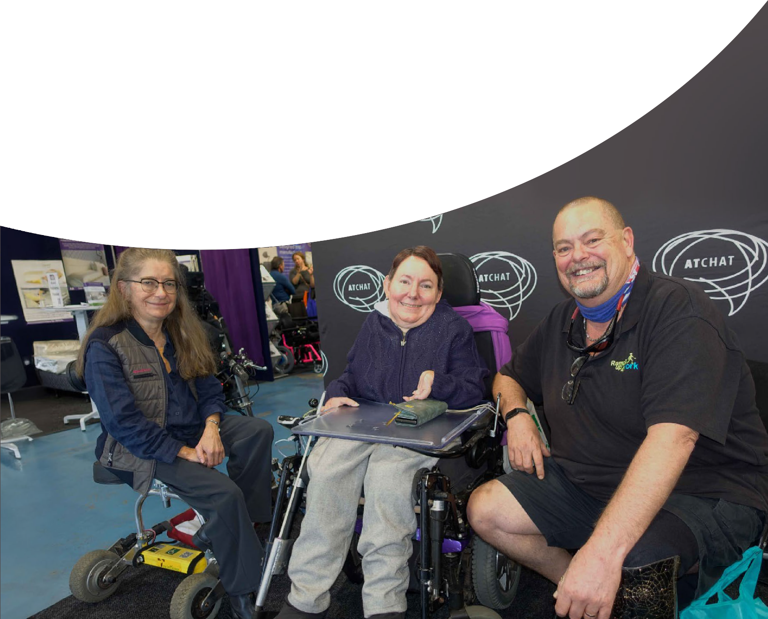

Page 9

Australian Standards
The team from Mobility and Accessibility for Children in Australia Ltd (MACA) have been working on a new Australian Standard AS 5384 Accessories for seat belts used in motor vehicles. This has been approved and is a voluntary standard which includes minimum requirements for postural support devices including design, construction, performance and information.
For more information please go the MACA website maca | First Australian standard for specialty harnesses and vests (macahub.org) or to read the overview and purchase the standard please go to AS 5384:2023 Accessories for seat belts used in motor vehicles (saiglobal.com) . Thank you to all those ATSA members who were involved in the development of this standard.
There is another standard under development for the use of lithium batteries in powered wheelchairs AS/NZS 7176.31 Wheelchairs, Part 31: Lithium-
ion battery systems and chargers for powered wheelchairs - Requirements and test methods. As many of you will be aware, there are no standards for lithium batteries as yet so it may be a case of something is better than nothing.
This is a difficult issue given the amount of press about lithium batteries and we would be very interested to hear members’ views on this proposed standard. Please contact Margaret at margaret.noonan@atsa.org.au.

ACCC

Businesses urged to remove unfair contract terms ahead of law changes.
The ACCC is encouraging businesses to review their standard form contracts and remove or amend any unfair contract terms before new penalties take effect.
From 9 November, changes to the Australian Consumer Law will prohibit businesses from proposing, using, or relying on unfair contract terms in standard form contracts with consumers and small businesses.
Read more here

NDIS update
The NDIS is upgrading their computer system and implementing a new provider portal. Providers
will transition to the NDIS new ways of working, including the new my NDIS provider portal, when the participants they support have NDIS plans in their new PACE computer system. The roll out of the PACE system is expected to take place gradually over the next 18 months.
Updates can be found on We’re introducing a new computer system and improving the way we work | NDIS Improvements

Australian Taxation Office
ATSA would like to thank member Steve Joyce and his team for working with us on obtaining from general advice from the ATO on the application of GST to AT, spare parts and repair services.
Click here to download the GST information sheet.
Page 10

Oceania Seating Symposium 2023 – Transformation: Changing Futures
Page 11
The Oceania Seating Symposium is the largest meeting of seating and positioning specialists in the Southern Hemisphere. Join us at the MCG in Melbourne from 21–23 November for this year’s event, with the special theme ‘Transformation: Changing Futures’.
The Symposium attracts dedicated clinicians, researchers, manufacturers and equipment suppliers, as well as professionals working in seating and positioning, postural management, wheeled mobility and associated technologies from around the world.
This year’s symposium will feature a number of exciting and knowledgeable Keynote Speakers, including Andrew Slorance, Dr Heather Feldner and Dr Huhana Hickey. The latest speaker has just been announced: former Australian of the Year, Dylan Alcott. Dylan will be having a fireside chat with Ryan Tilley in a special event supported by Rove Wheelchairs.
The Symposium also features an exciting program full of insightful presentations, a jam-packed exhibition area, and our sponsors who are making the entire event possible. There are still sponsorship opportunities available, so please get in touch if you want to be involved in this exciting event.
For more information – including sponsorship opportunities, the full program and how to register – please visit oceaniaseatingsymposium.com

DITCH THE DISTRACTIONS…. –

By Greg Gunther and Joshna Daya, Your Business Momentum

In the fast-paced world of business, staying focused is often easier said than done. As a business owner and leader, you’re constantly bombarded with emails, phone calls, meetings, and an endless stream of tasks demanding your attention. It’s no wonder distractions can easily derail your focus and productivity. However, mastering the art of moving beyond distractions is essential for success in today’s competitive landscape and allowing you to execute your business strategy.

Understanding the impact of distractions
Distractions can have a significant impact on you, your team and your business. They can lead to wasted time, missed opportunities, decreased productivity, and increased stress levels.
Research from a University of California study1 has shown that it takes an average of 23 minutes and 15 seconds to regain full concentration after being interrupted. Multiply this by the numerous distractions you and your team encounter everyday, and you can see how it can severely hinder your progress.

Identifying common distractions
Before we explore strategies to combat distractions, it’s crucial to pinpoint the common culprits that can hinder your focus. Emails constantly flood inboxes, diverting attention. Social media consumes valuable time and attention.
Excessive or poorly managed meetings can hinder productivity. Multitasking, although frequently praised, erodes concentration and impacts results. These distractions are particularly detrimental, often leading non-essential tasks to overshadow strategic initiatives.

The consequences of distractions: Loss of traction
When distractions take over, your business loses momentum and in turn, your business becomes less likely to reach its goals. A range of negative consequences result from this loss of traction including employee morale regresses, opportunities can be missed, reduced productivity in the workplace
and the potential for financial instability.

Questions?
Please email events@atsa.org.au
If there is a business topic or education session you would like to see in the 2024 calendar please let us know.

Page 12

Your Business Momentumcontinued...

The question remains: How can businesses effectively address these distractions?

The solution: Increased traction by implementing strategy
To beat the distractions in your business, there are 5 key areas that every business leader needs to implement.
- Get absolutely clear on the bigger picture vision and purpose of the organisation
- Break up your plan into bite-sized chunks
- Build your business functional structure
- Systemise your business
- Align your team. Do you have the right people in the right seats?

The benefits of moving beyond distractions
As a business owner, it’s crucial to move beyond distractions to regain your focus and drive your business forward. This 14-page whitepaper will help you navigate the challenging distractions of today’s business world with tangible solutions,
proven strategies, and real-world case studies that exemplify the power of strategic implementation
in any business setting. Learn more about moving beyond distractions by downloading this whitepaper.

About Greg Gunther and Joshna Daya - Founders and Directors of Your Business Momentum
Greg and Joshna are seasoned business advisors and mentors with a passion for helping organisations get clear on their strategy and implement it. With over 30 years of combined business and professional experience, they have guided numerous established, rapidly growing businesses towards success.
They understand that no two businesses are the same, so a cookie-cutter approach just won’t work. They founded Your Business Momentum,
a professional services firm, on the belief that strategy and execution go together, and through focused implementation comes real results. Visit www.yourbusinessmomentum.com.au to know more.

1 Mark, G., Gudith, D., & Klocke, U. (2008). The Cost of Interrupted Work: More Speed and Stress. Retrieved from https://ics.uci.edu/~gmark/chi08-mark.pdf

Page 13

Insurance Solutions for
ATSA members
We have partnered with a number of specialist insurers with experience in underwriting Assistive Technology risk to provide
cost effective solutions for ATSA members.

Proven results. Since inception in 2019 the partnership with Oracle Group has
provided members with insurance solutions and savings. Most importantly 100% of member claims have been settled.
Brendon Watson is your dedicated broker managing all enquiries including questions, quotes, alterations and claims. A self employed Authorised Representative of the Oracle Group with over 25 years industry experience looking after the interests of ATSA members. To find out more please contact
Brendon on 0433 166 036 or brendon.watson@oraclegroup.com.au

- Public & Product Liability
- Professional Indemnity
- Business Insurance
- Cover for Goods on Hire, Trial or Loan
- Management Liability
- Cyber
- Landlords Insurance
- Transit Insurance
- All forms of insurance

Support ATSA
Issued: October 2023
“Brendon Watson from Oracle Group Insurance has proven his worth and experience to us in the Assistive Technology field, providing well-priced policies where others were either exorbitantly priced, or wouldn’t insure at all – I could recommend anyone in the same sector talk to him for insurance.”
“Insurance has always been my least favourite task, but working with Brendon has changed this for me. He has taken the time to explain, simplify and streamline at every step. I also see I have previously wasted money being incorrectly categorised for risk. Having someone take the time to understand what my business really needs means I now feel confident that I have all the right cover in place.”

25% of our brokerage is paid to ATSA assisting to advance the interest of the industry

Australia’s foremost assistive technology event
CANBERRA
8-9 NOV 2023
EXHIBITION PARK (EPIC)
BY THE INDUSTRY FOR THE INDUSTRY

REGISTER
NOW

ADELAIDE

6-7 MARCH 2024
ADELAIDE SHOWGROUND

SYDNEY

22-23 MAY 2024
SYDNEY SHOWGROUND

BRISBANE

29-30 MAY 2024
BRISBANE CONVENTION & EXHIBITION CENTRE

1300 789 845
www.atsaindependentlivingexpo.com.au

Organised by Media Partners

