ATSA Newsletter
MAY 2024
www.atsa.org.au

CEO Welcome
As we roll towards what is always ATSA’s busiest month of the year, with our Sydney and Brisbane expos and the Awards night just around the corner, the ATSA team once again look forward to catching up with
our members at these fabulous events. In the meantime, take a few minutes out of your hectic day to catch up on what’s
happening across the wider industry that can be found in this edition of our newsletter.

Serena Ovens
CEO, ATSA
REGISTER HERE

SYDNEY
22-23 MAY 2024
SYDNEY SHOWGROUND

BRISBANE
29-30 MAY 2024
BRISBANE CONVENTION & EXHIBITION CENTRE

FREE TO ATTEND REGISTER NOW
130+ exhibitors. Australia’s largest display of assistive technology and daily living aids – DESIGNED TO MAKE LIFE EASIER
1300 789 845
www.expo.atsa.org.au

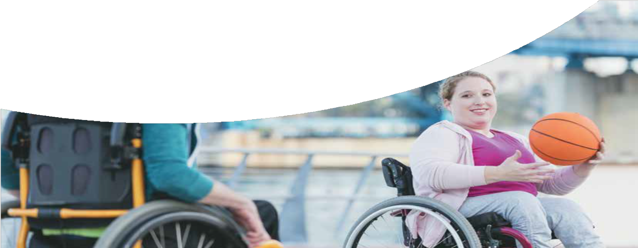
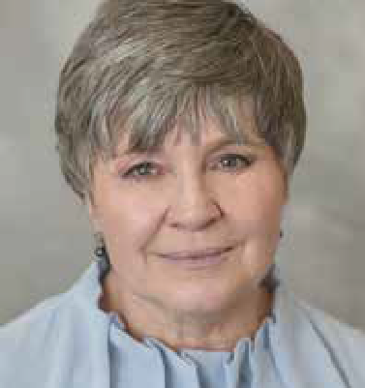
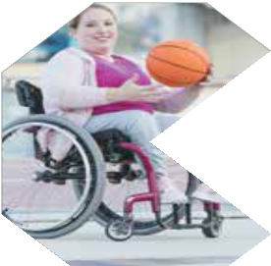
There’s still much reform in progress in both the Aged Care and NDIS space, and as you may have seen, ATSA is particularly concerned about the upcoming pilot of a
government loan pool model touted for the Support at Home reform. I wanted to take this chance to thank those members who have responded to our call for contributions to a fighting fund to undertake research that can support our belief that this is a huge step backward for AT procurement and in meeting participant AT needs. If you haven’t yet contributed and have the means, please use the link provided to you in the email request sent out late April! Every dollar counts!
We’ve also been busy responding to a number of legislative and regulation changes in the NDIS ACT, NDIS registration and Australian Standards – we’ll provide our final submissions to members shortly, but again thank those who have provided input to these works. Feedback and case studies from the sector greatly strengthen our position.
This issue also provides an update and information sheets on lithium batteries and safety, small business myths and much more - read on to catch up on all the news.
See you at an Independent Living Expo soon!
Serena

Page 1

Important dates In this issue

Page

2024

ATSA Independent Living Expo, Sydney
22 – 23 May 2024

ATSA Independent Living Expo, Brisbane
29 – 30 May 2024

ATSA Awards Dinner, Brisbane
29 May 2024

The Accessible & Inclusive Tourism Conference, Melbourne
27 August 2024

Rehacare – Dusseldorf, Germany
25-28 September 2024

Home Care & Rehabilitation Exhibition 2024 – Tokyo, Japan
2-4 October 2024
Australian Assistive Technology Conference 2024 - Gold Coast 6-8 November 2024

ATSNZ Disability Expo, Auckland
6-7 November 2024

ATSNZ Disability Expo, Christchurch
20-21 November 2024

ATSA

Board Members

Chair
Nikolas Witcombe (Board Appointed)

Vice Chair
Philippa Bell (Board Appointed)

Financial Director
Andrew Webster (Country Care Group)

Directors
Amin Akbarian (Mobility Engineering) Matthew Butterworth (Magic Mobility) Martin Hoffman (Aidacare)
Michael Linke (Vision Australia, Board Appointed) Stewart McDonagh (Independent Living Specialists) Jeff Watters (Automobility)
ATSA News 1
Important Dates 2
What ATSA members have been up to 3
Industry Updates 9
Oracle Group Insurance 10
Employsure Workplace Confidence 11
ATSA Expo Special Event -
Book Signing & Giveaway 13
VOTE NOW! Best New Product Awards 14

Suite 302, Level 3 Lawson Place 165-167 Phillip St
Sydney NSW 2000
Phone: (02) 8006 7357
Email: info@atsa.org.au Website: www.atsa.org.au
ABN: 58 628 080 517

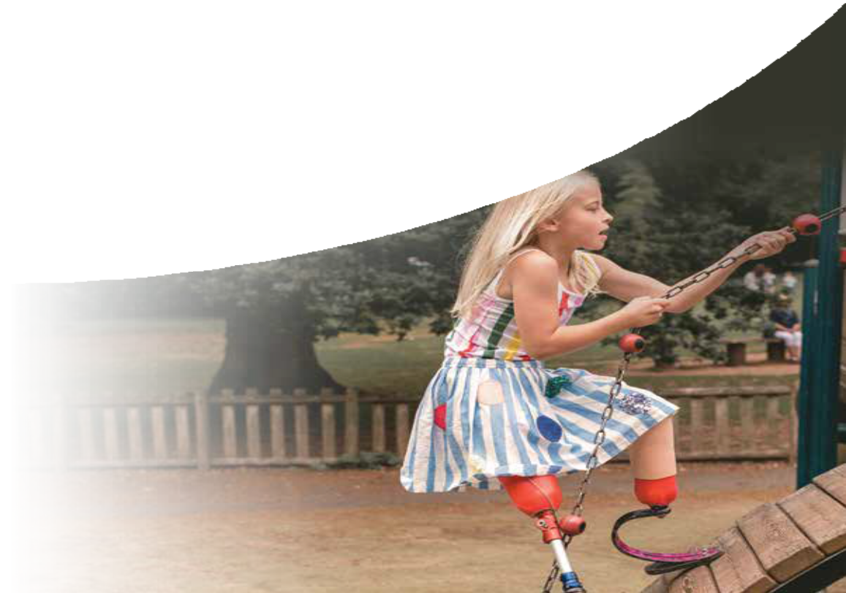

Page 2

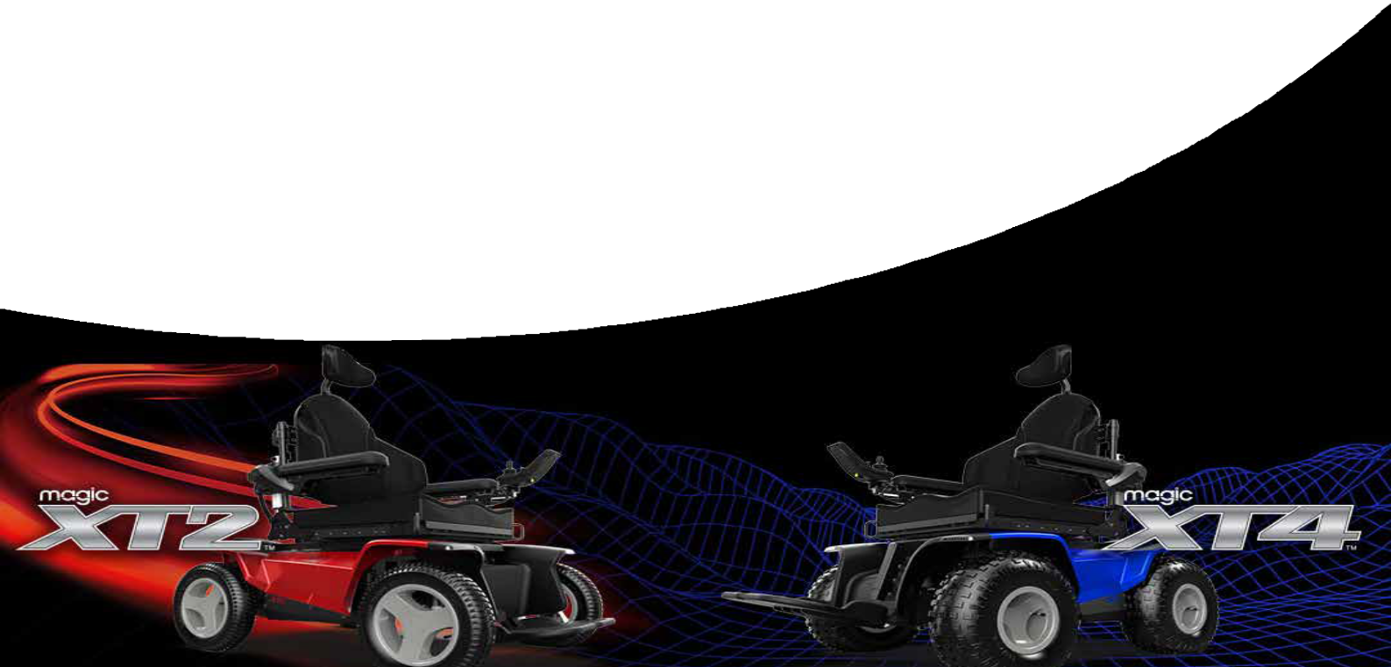
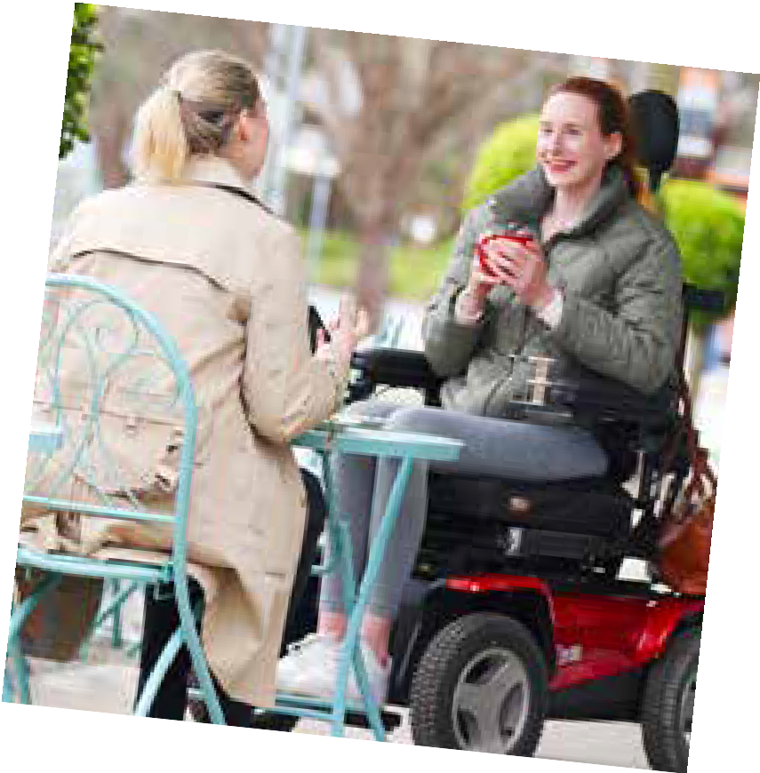
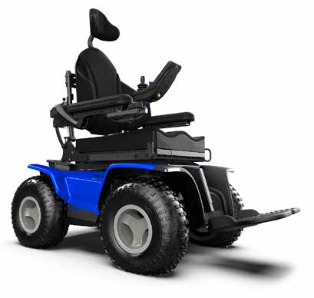
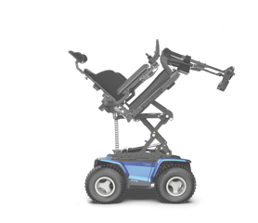
OUTDOOR MOBILITY:

the next generation
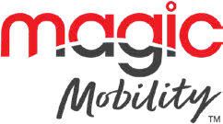

With patented front and rear suspension, massive batteries and servo powered steering, Magic Mobility’s new XT range enables you to get further outdoors or go more off-road than ever before.
For 30 years Magic Mobility has been inspired by the challenge to enable people with limited mobility to live their lives to the full, free to enjoy the great outdoors like other people often take for granted.
As leading powerchair innovators, our aim is to constantly improve on satisfying wheelchair users’ desire to feel good (and look good!), go further and be more in control of their chair – and, in turn, their own lives.
Since we first launched the Magic 360 a few years back, we have been focussing on developing our range of off-road chairs, designed specifically for outdoor exploration and enjoyment.
The result of our efforts in research and development are not one, but two brand new outdoor powerchairs, designed to address many of the unmet needs and lifestyle aspirations expressed via our users’ feedback.

OUR ALL NEW XT2 CRUISER. YOUR JOURNEY, DONE YOUR WAY
The XT2 is in many ways a totally new type of powered wheelchair.
With four large Urban wheels on a longer wheelbase, this powerful rear wheel drive features two 850-Watt motors and has larger batteries than on any chair we have ever made.
Introducing the Magic
Mobility XT2 powerchair

Page 3

Outdoor Mobility continued...

The XT2 is designed to cruise effortlessly over footpaths, bike tracks, grass, tree roots and gravel pathways typical of the areas where most people live, work and play.
The addition of a new level of excellence in steering, our servo-powered steering module not only provides superior, reliable control at top speeds, but also reduces the amount of energy required to drive the chair. The result is a range that has been real- world tested in Urban environments (carrying a 100 kg user) achieving our best results for a real world test to date. And all on a single charge.
With the same superior seating comfort and powered seating and legrest options as any other Magic Mobility powerchair, an XT2 user can cruise outdoors in comfort for hours with peace of mind and confidence, regardless of the everyday off-road terrains they encounter on their journey.

OUR UPGRADED OFF-ROAD POWERHOUSE, THE BRAND-NEW XT4. OFF-ROAD, OFF THE SCALE!
The XT4 is our latest and greatest off-road 4×4 powerchair, built on the experience of our world famous and much loved Extreme X8.
Thanks to the all new patented front and rear suspension designed and developed by our Australian engineers and combined with our unique new servo steering module, the XT4 now provides greater comfort, stability and traction over extreme off-road terrains than we’ve ever provided before.
With larger batteries as standard and the improved efficiency of servo-powered steering, the XT4 is designed to take you further off-road.
Its precise and intuitive powered steering and improved control in both forward and reverse removes the requirement for a separate steering lock, which adds an extra level of convenience for XT4 users.
Feel more stable and comfortable across slopes and up steep inclines in the Magic Mobility XT4
As explained in more detail here, the XT4’s brilliant new suspension system is designed to keep all four wheels on the ground. This provides superior traction even across undulating terrains.
Adventurous Magic Mobility customers, users and testers who regularly use all terrain wheelchairs have tested the XT4 in real-world conditions. They say it is noticeably more comfortable in terms of reduced side-to-side movement, and that it feels more stable, particularly when driving sideways on an incline or up a steep hill.
Both the XT2 and XT4 share the same sleek and
updated contemporary body styling and are fitted with removable body panels to enable easy access for servicing and repairs.

SUMMING UP – SO MUCH BETTER FOR GETTING OUTDOORS
Our brand-new XT family of power chairs have been designed to:
- Look good – sleek, contemporary styling with smarter design features
- Feel good – more comfortable suspension and greater stability to support the user over rough terrain
- Go further – extended off-road and all-day cruising range on a single charge
- Be more in control – precise servo steering and improved traction across all terrains

So…when and where can you get one?
The XT2 and XT4 will become available to test drive and order in Australia and New Zealand from April 2024, with availability extending to other countries and regions from 2025.
In the meantime, you can register your interest in hearing more about the timing of availability here, or enquire with any specific questions you may have about the new chairs or our entire powerchair and accessory range here.
Click here to find your local agent and trial our range of powerchairs across your terrain.
Please view our disclaimer here.

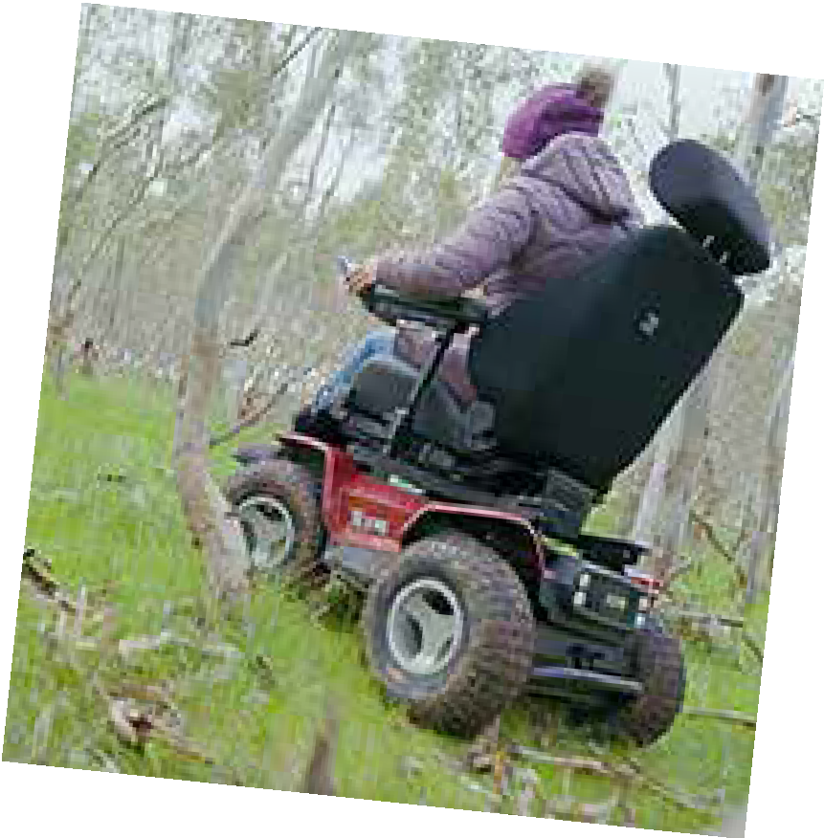
Page 4
Stable & comfortable on
slopes and inclines.

Harnessing the Power of Assistive Technology

The Smart Display Revolutionising Daily Living for Individuals with Cognitive Challenges
Assistive Technology is continuously advancing at an incredible pace, it is heartening to witness the employment of devices that not only keep up with our digital lives but also enrich the daily experiences of individuals living with cognitive challenges. Among these innovations, the Bella Linda - SMART DISPLAYS shine as a beacon of
hope and convenience, particularly in the National Disability Insurance Scheme (NDIS) space.
In the case of Lee Anderson, a busy man with a young family, a fast-paced lifestyle and a love for camping and the outdoors. In 2018, he sustained an Acquired Brain Injury (ABI) affecting, among many things, his short-term memory consolidation, planning and organisation and, subsequently, his ability to adequately manage the daily schedule at home. After many months and years of trialling varied strategies to compensate for his memory, Lee turned to, and now heavily relies on, the use of digital calendars (Google) to prioritise and capture the details of his family’s day-to-day agendas as well as household needs.
Despite the level of detail contained in Lee’s calendar, he constantly battled with the problem of his schedule being “hidden” behind the lock screen of his devices and hidden away from those supporting him on a daily basis.
After coming across the Bella Linda - SMART DISPLAYS powered by DAKboard, Lee was able to bring his family organisation and planning to life through innovative and stylish displays.
With its flexible design and connectivity, Bella Linda addresses the unique needs of Lee, enabling a significant enhancement to his quality of life.
Customisable in nature, the SMART DISPLAY offers a plethora of features:
Connects over Wifi – Seamless integration within Lee’s home environment.
Large Digital Clock and Text Sizing Options – Catering to various levels of visual acuity and preference.
Weather Forecast – Keeps Lee attuned to the environment, promoting preparedness and mental comfort.

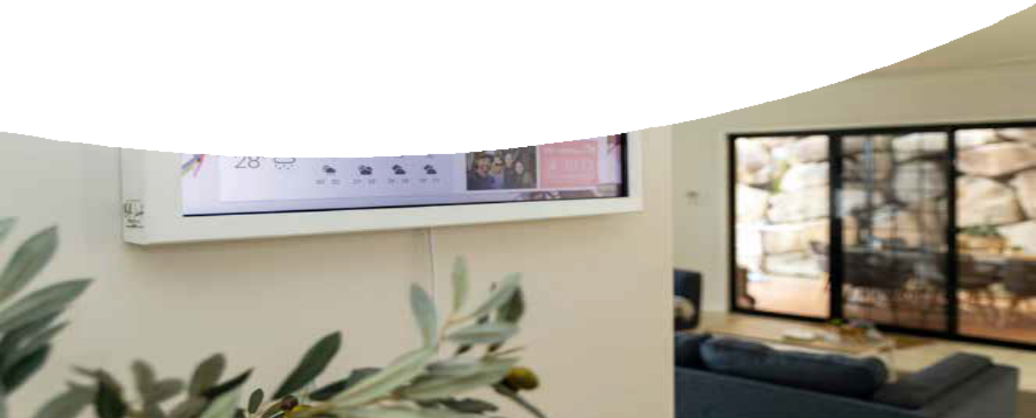
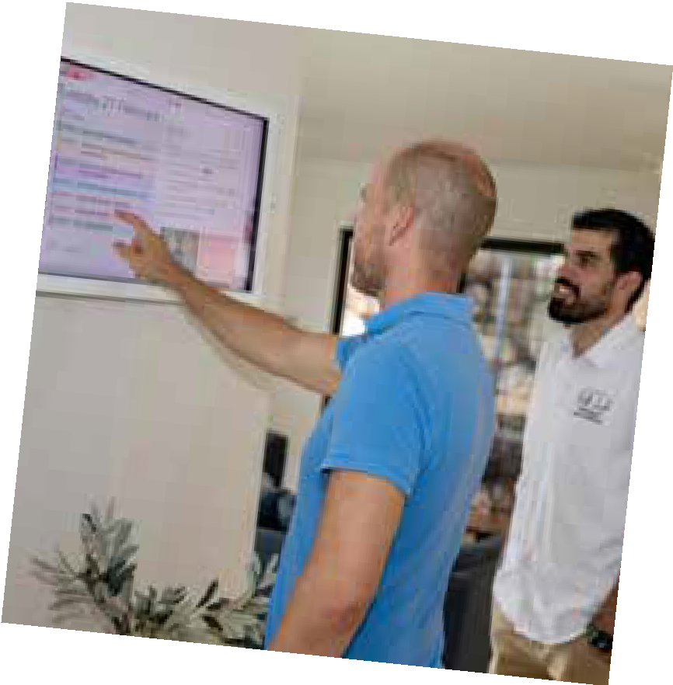
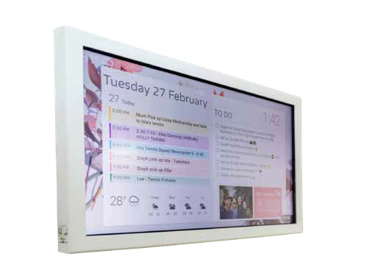

Page 5
Lee using the Bella Linda -
SMART DISPLAY

Harnessing the Power of Assistive Technology continued...

Personal Photo Sharing – A touch of personalisation, bridging memories and daily experiences for Lee and his family.
Reminders and To-Do Lists - Creating independence through manageable tasks and schedules.
These features come with the optional Touch Screen feature, encouraging interaction and responsiveness.
“My calendar, to-do lists, as well as other important information are now beautifully displayed in a prime location in my house, enabling not only me but my family and others who assist in the house to see, at a glance, the vital detail of the way our household is running,” says Lee. “Our Bella Linda - SMART DISPLAY is beautifully framed and presented and takes pride in its place in the central hub area of our house,” he added.
Since installing the Bella Linda - SMART DISPLAY, Lee has noticed a dramatic improvement in his ability to manage and process the vast amount of information contained within the family calendar. He has been delighted by the enhanced memory support the display provides and loves the functionality, ease of use, accuracy and timeliness of the information displayed on the screen.
The feature that has really appealed to Lee and his family is the ability to create and switch
between different displays and “widgets” within the software. On the main display, he was able to create an interactive countdown timer for family milestone events such as birthdays, display the weather forecasts for the coming days, and display information contained in supported apps such as Google Tasks. When the busy day is over, or the weekend comes around, and friends come over to
visit, the private family information is hidden away at the touch of a button behind a new screen linked to Google Photos displaying a hand-picked selection of his family’s favourite photos and memories. “This feature has created such a talking point with the family, as precious memories are displayed in vibrant colour for all to enjoy,” Lee adds.
For occupational therapists, carers, and family members looking to provide innovative support to their loved ones, Bella Linda - SMART DISPLAYS represent a leap forward in Assistive Technology. More than just a device, a companion that understands the rhythm of daily living
and fosters an environment of control, independence, and joy.

www.bellalinda.com.au

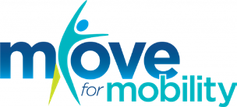

1-31 May 2024
Move for Mobility is Invacare’s first global fundraiser in partnership with Free Wheelchair Mission, an international non-profit humanitarian organization dedicated to providing wheelchairs to under-resourced countries around the world.
In May, hundreds of Invacare employees around the world are taking part by doing physical activities and challenges to help raise awareness and funds for this great cause. For every $96 raised, a wheelchair is gifted to communities with no access to mobility and very often healthcare.
If you would like to support team Invacare on this challenge, you can donate here: www.invacaremoves.org.

Page 6

Embark on a Virtual Experience with Theorem

Theorem continues to redefine the power lift recliner industry with the introduction of
Augmented Reality (AR) technology. Integrated into Theorem’s website, AR allows you to experience their range in your own environment.
“This tool is a game-changer for us. It empowers our customers to envision our chairs in their homes before making a significant decision.” remarked Darren Rose, Director of Sales and Marketing at Theorem.
In addition to the AR feature, each product is now showcased in immersive 3D. This feature enables you to explore every detail and witness the chair’s key functions in action. The comprehensive 3D view consolidates the entire range into one accessible platform.
The next phase elevates user experience by using the AR feature to project the 3D product and its functions into the real world.
In 2023 Theorem introduced their ground-breaking app-controlled power lift recliner, the ‘Winslow.’ Building on this innovation, 2024 sees the introduction of a height-adjustable headrest and a petite option to the Winslow design.
Accessing Theorem’s AR technology is simple: scan the QR code with your smart device, select your desired model and colour, and seamlessly visualize the chair in your living space. Experience its functionality firsthand before making your purchase decision.
Theorem Power Lift Recliners combine cutting-

edge technology with unparalleled comfort to provide users with an enhanced seating experience. With features such as AR integration, 3D viewing capabilities, and innovative designs like the app- controlled ‘Winslow,’ Theorem is revolutionizing the power lift recliner industry. Whether it’s visualizing how a chair will fit into your home or experiencing its functionality firsthand, Theorem empowers customers to make informed decisions and enjoy ultimate relaxation.
For more information on Theorem’s product offering or to view the full range, please visit www.theorempowerliftrecliners.com

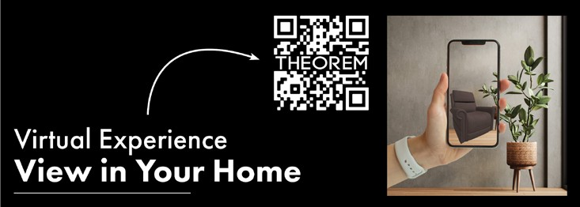
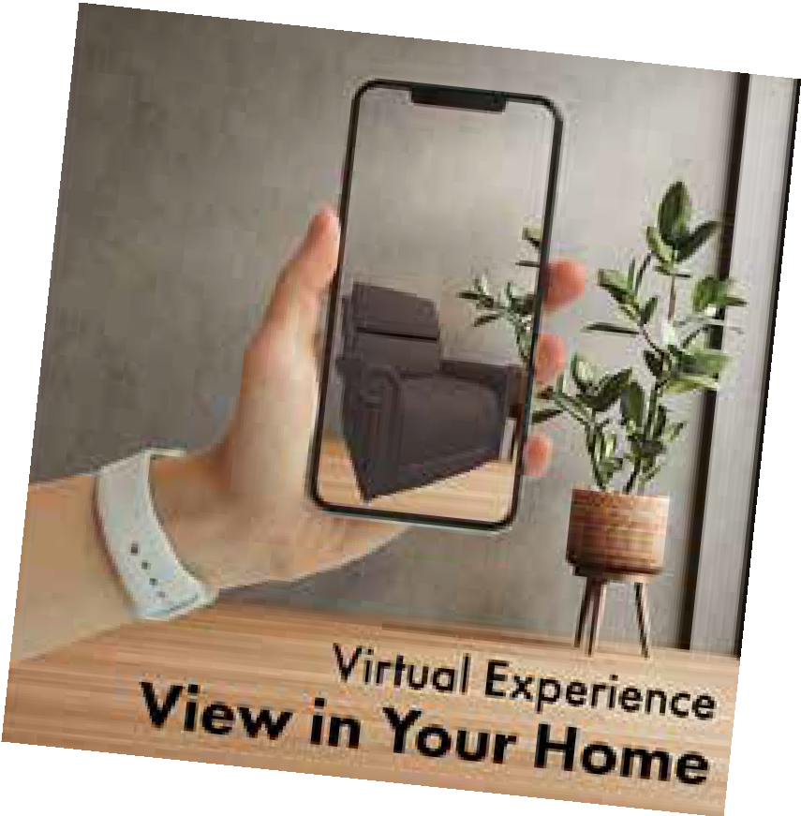

Page 7

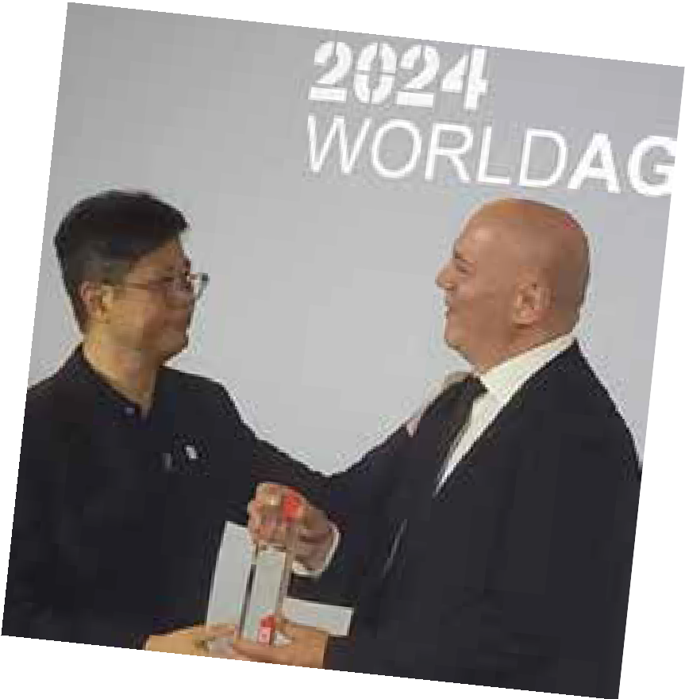
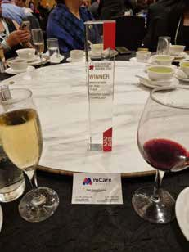
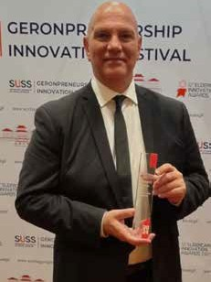
INTERNATIONAL AWARD WINS

HOT OFF THE PRESS!
mCare Digital took home the award for Innovation of the Year
- Assistive Living Technology, best assistive living technology at the 12th Asia Pacific Eldercare Innovation Awards 2024 last night in Singapore.
Quote from Peter Apostolopoulos, Founder & Managing Director at mCare Digital after the win, “We feel incredibly humbled and proud at the same time that an idea, which sprouted 12 years ago as a way of helping our ageing father, is now an internationally recognised and celebrated solution for the ageing population in the Asia Pacific.
Having our mCareWatch shortlisted as a finalist alongside remarkable innovations like the eAlertCare System by Guardman Products Limited (Hong Kong), AGEasy by Antara Senior Care (India), Buddy App by Bolton Clarke (Australia) and Medication Management App by PharmCare Technology Limited (Hong Kong) was already an incredible achievement. But winning the award category is simply remarkable.
Although this particular award was in the category of assistive living technology that enables independent living for the ageing population, we are equally committed to supporting people with disability and those concerned about their personal safety, such as circumstances of domestic and family violence or as staff safety solutions.”
Peter Apostolopoulos accepting
his award in Singapore.

Page 8

ATSNZ DISABILITY EXPOS

Call for Abstracts

Attention all innovators, researchers, clinicians, and industry professionals! Showcase your expertise and be part of the Professional Seminar Series at the ATSNZ Disability Expo's!
ATSNZ are inviting abstract submissions from a diverse range of presenters, including individuals with or affected by disability, researchers, clinicians, service providers, policy makers, occupational therapists, physiotherapists, and allied health professionals.
This is your chance to share your insights, research findings, and best practices with our Expo

Information Paper on Lithium Batteries
attendees at either or both the Auckland and Christchurch Expo!
Don't miss out on this exciting opportunity to be part of the conversation!
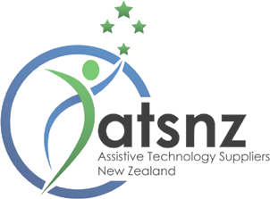
Visit the Expo website for more information and to submit your abstract by Wednesday 31 July, 11pm. Let's make a difference together!
www.atsnzexpo.nz

This link will take you to the latest research by
ATSA on the regulations, standards and other information relating to Lithium-ion batteries.
As there is no one regulator in Australia, the purpose of this paper is to provide you with organisations you can go to when you want to find out more about the battery in an AT device.
Member Information Paper
Click here for the latest research by ATSA on the regulations, standards and other information relating to Lithium-ion batteries.
Contact: Margaret Noonan
March 2024
Assistive Technology Suppliers Australia
Suite 302, Level 3 Lawson Place
165 -167 Phillip St Sydney NSW 2000
02 8006 7357
www.atsa.org.au
Lithium-ion Batteries

Page 9
info@atsa.org.au

Insurance Solutions for
ATSA members
We have partnered with a number of specialist insurers with experience in underwriting Assistive Technology risk to provide
cost effective solutions for ATSA members.

Proven results. Since inception in 2019 the partnership with Oracle Group has
provided members with insurance solutions and savings. Most importantly 100% of member claims have been settled.
Brendon Watson is your dedicated broker managing all enquiries including questions, quotes, alterations and claims. A self employed Authorised Representative of the Oracle Group with over 25 years industry experience looking after the interests of ATSA members. To find out more please contact
Brendon on 0433 166 036 or brendon.watson@oraclegroup.com.au

- Public & Product Liability
- Professional Indemnity
- Business Insurance
- Cover for Goods on Hire, Trial or Loan
- Management Liability
- Cyber
- Landlords Insurance
- Transit Insurance
- All forms of insurance

Support ATSA
Issued: October 2023
“Brendon Watson from Oracle Group Insurance has proven his worth and experience to us in the Assistive Technology field, providing well-priced policies where others were either exorbitantly priced, or wouldn’t insure at all – I would recommend anyone in the same sector talk to him for insurance.”
“Insurance has always been my least favourite task, but working with Brendon has changed this for me. He has taken the time to explain, simplify and streamline at every step. I also see I have previously wasted money being incorrectly categorised for risk. Having someone take the time to understand what my business really needs means I now feel confident that I have all the right cover in place.”

25% of our brokerage is paid to ATSA assisting to advance the interest of the industry

25 common myths around WHS/OHS

Health and safety in the workplace is a critical aspect of ensuring the well-being of employees & workers, and compliance with Safety regulations. However, there are many common myths and misconceptions surrounding this topic that can potentially expose the business (and their workers).

Myth 1: “WHS is only for high-risk business. We are low risk (I.e. Office Based) so don’t need it”:
Reality: EVERY business has hazards & risk. It is a legal requirement to create a safe workplace from physical and psychological hazards. While some industries may have more apparent risks, safety is essential in all workplaces, including offices, retail stores, and other seemingly, low-risk environments.

Myth 2. “We don’t need it as we have workers compensation insurance?”:
Reality: Workers’ compensation is a form of insurance payment to employees if they are injured at work
or become sick due to their work. It is a legal requirement. Workers’ compensation includes payments to employees (and contractors who charge mainly for labour) to cover their medical expenses and rehabilitation plus wages while they’re not fit for work.

Myth 3. “Small businesses don’t need to worry about WHS/OHS”:
Reality: Every business, regardless of its size, has a legal and moral obligation to provide a safe working environment for its workers. Non-compliance can result in legal consequences and penalties.

Myth 4. “We work safely on the job, so we don’t need the paperwork. They know what is safe and what isn’t.”:
Reality: If there is a WHS incident, you need to be able to show evidence of a documented WHS Management System in place for your workers.
Myth 5: “We do all of our training on the job, so don’t need to have anything documented. It is just common sense, so it doesn’t require formal training.”
Reality: Some employers and employees believe that once they have received initial safety training, there is no need for further education or updates. However, regular safety training is essential for reinforcing knowledge, addressing new hazards, and ensuring compliance with changing regulations.
Myth 6: “WHS is only about physical safety”:
Reality: While physical safety is a significant component, WHS also encompasses psychological hazards like workplace stress, bullying, and harassment which can have severe consequences and should be addressed alongside physical safety concerns.

Myth 7. “Risk Assessments. We know what the risks & hazards are in the business. We don’t need to do risk assessments”:
Reality: Risk Assessments are integral to WHS compliance. You are documenting the processes that you have in place to minimise risk to your workers.

Myth 8. “Our contractors have their own insurance, so we don’t need WHS for them”:
Reality: You are legally responsible for the Health & Safety of all of your workers (this includes contractors & sub-contractors and even their
employees, labour hire, volunteers & work experience students). They are all “workers” under Health & Safety legislation. If your “workers” have an incident on your premises, you can still be held responsible.

Myth 9. “We talk about Safety all the time, so we don’t need to document it. They know what they are doing”:
Reality: Documented safety discussions with the workers (Toolbox Talks) – with two-way communication, is an integral part of the WHS Management System. It is also a legal obligation under WHS legislation.

Myth 10. “We have SWMS (Safe Work Method Statements), so we have it all covered….”:
Reality: SWMS are supporting (site specific) documentation only that sets out the high-risk work activities to be carried out at a workplace, the hazards arising from these activities and the measures to be put in place to control the risks.

Myth 11. “Inductions. We are not a construction company, so they are not required”:
Reality: Inductions are an integral part of any WHS compliance. You need them for any job where you start work, for ANYONE working in the business.

Myth 12: “Health & Safety is only the responsibility of the safety officer or manager”:

25 Myths Around Work Health & Safety continued...

Reality: WHS is a shared responsibility that involves everyone in the organization, from top management to employees. Everyone should be aware of WHS policies and actively participate in maintaining a safe workplace.

Myth 13: “Safety equipment makes the workplace 100% safe”:
Reality: While safety equipment is essential, it’s just one part of a comprehensive WHS strategy. Proper training, hazard identification, and risk management are equally important in ensuring workplace safety.

Myth 14: “Accidents are bound to happen; there’s no way to prevent them completely”:
Reality: While it’s impossible to eliminate all risks and accidents, proactive measures, regular training, and continuous improvement can significantly reduce the likelihood (and also severity) of workplace incidents.

Myth 15: “WHS is too expensive and time- consuming”:
Reality: Investing in WHS can actually save businesses money in the long run by reducing absenteeism, turnover, and potential legal costs associated with workplace incidents. Plus, a safe workplace can boost productivity, employee morale and retention.

Myth 16: “Employees will always follow WHS rules if they understand them”:
Reality: While understanding WHS rules is essential, compliance also depends on workplace culture, leadership, and enforcement of safety protocols.

Myth 17: “Once a WHS program is in place and set up, there’s no need to review or update it”:
Reality: Workplace hazards and regulations can change over time. Regular reviews and updates to the WHS program are essential to ensure it remains effective and compliant with current standards and regulations.

Myth 18: “Accidents only happen to others”:
Reality: There is a misconception that safety regulations are excessive and only serve to slow down work processes. However, well-implemented safety measures can actually enhance productivity by reducing downtime due to accidents and injuries.

Myth 21: “Wearing safety equipment is optional”:
Reality: Some employees believe that wearing personal protective equipment (PPE), such as helmets, gloves, or safety goggles, is optional. In reality, PPE is often required by law and is crucial for protecting against various workplace hazards.

Myth 22: “If an accident happens, it’s the employee’s fault”:
Reality: Blaming the victim is a harmful myth that ignores the importance of identifying and addressing underlying safety issues. Accidents are often the result of multiple factors, including inadequate training, faulty equipment, or unsafe working conditions.

Myth 23: “It’s okay to take shortcuts to get the job done faster”:
Reality: Taking shortcuts to save time or effort can compromise safety. It is essential to follow established procedures and protocols to ensure that work is completed safely and efficiently.

Myth 24: “Our workers have all their licences in place (I.e. To use a forklift, drive a car, use certain plant/machinery, Etc), so we are all covered”
Reality: Having the necessary accreditations or licences is only the beginning. Whilst it does allow them to legally operate the item in question, WHS compliance involves a lot more than just holding a licence.

Myth 25: “Minor Accidents Aren’t a Big Deal”:
Even minor accidents can lead to significant injuries or long-term health issues if not addressed promptly. It’s essential to report and treat all
workplace incidents seriously.
In conclusion:
If I can assist your business in any way, around your managing your legal Fair Work or Safe Work obligations, please do not hesitate to contact me.

Brett Winduss
Business Development Manager Employsure
Ph: 0418 935 057
Email: brett.winduss@employsure.com.au
LinkedIn: https://www.linkedin.com/in/brett-winduss/
Reality: Many people believe that workplace accidents will not happen to them, assuming that they are careful enough. This complacency can lead to risky behaviours and neglect of safety protocols.
Myth 19: “Safety measures are just a formality and don’t make a difference”:
Reality: Some people think that safety procedures and equipment are unnecessary and do not contribute to preventing accidents or injuries. In reality, proper safety measures can significantly reduce the risk of accidents.
Myth 20: “Safety regulations are too strict and hinder productivity”:

Page 12

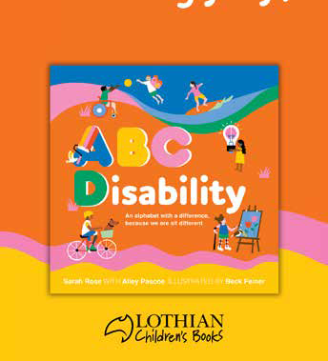
BOOK SIGNING & GIVEAWAY
Sydney: Wednesday 22 May 2024
Brisbane: Wednesday 29 May 2024
We are delighted to be able to give the first 600 attendees at each expo,
a free copy of “ABC Disability”.
Sarah will also be signing books from noon on Wednesday (for one hour). Come see us at stand the ATSA stand
to get your copy signed!

Introducing “ABC Disability: An Alphabet with a Difference”! Join us for a journey through the alphabet, redefined through the lens of diversity and inclusion. Authored by the remarkable Sarah Rose, a three- time Paralympian swimmer and a true champion of disability rights.
Sarah’s story is one of resilience, triumph, and advocacy. Having represented Australia on the world stage, she now dedicates her life to breaking barriers and reshaping perceptions. Through her podcast, “A Very Rosie Podcast,” she amplifies the voices of those who have dared to chase their dreams.
But Sarah’s influence extends far beyond the pool. As a passionate advocate for diversity and inclusion, she’s a regular presence on national television and an esteemed member of Paralympics Australia’s Athlete Commission. Her mission is clear: to pave the way
for a future where disability is celebrated, not sidelined.

Page 13

Finalists for Best New Product Award are:

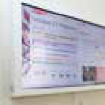  Bella Linda -  Smart Display  Bella Linda  The Bella Linda Smart Display powered by Dakboard is a cutting-  edge digital display solution designed to seamlessly integrate into homes, oﬃces, or caretaker spaces. Featuring a sleek design and vibrant high-resolution screen, the Smart Display oﬀers a versatile platform for showcasing customisable content and information.  With its WiFi connectivity, users can easily access and update content remotely, ensuring that displayed information remains current and relevant. Whether it’s displaying an individual’s calendar events (or multiple calendars), weather forecasts, personal photos, to-do lists, and much more, the Smart Display provides a dynamic and engaging visual experience. | 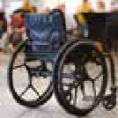  Eppur –  Dreeft Wheels  Muve Tech  Inspired by Dutch bicycles, the Eppur Dreeft wheels incorporate a  back-pedal braking system at their centre, enabling the user to activate a brake by lightly pulling the handrail backwards. They are designed for  injury-free braking. Even for people with low muscle strength, the Eppur Dreeft braking system makes handling slopes and bends safer and more comfortable.  With Dreeft, you can slow down, turn, and reverse without any friction in your hand, and with 5x less eﬀort helping to preserve shoulder and hand strength. | 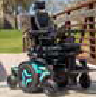  M Corpus VS  Permobil  M Corpus VS brings customisable power standing to the manoeuvrability of a  mid-wheel drive base. You’ll see the same cutting-edge technology and ergonomic design that you know from Permobil, including the fully programmable standing sequences that enable you to find the perfect position using supine, semi-recline, or sit-to-stand techniques. You can further customise your standing solution with the adjustable chest support, new lightweight swing away knee supports, and a power articulating footplate.  We also know how important stability, traction, and comfort are to your stand and drive experience, so we’ve got  you covered with our new DualLink suspension with fully adjustable, oil-dampened shocks and excellent low-end torque.
Bold, Beautiful Wheel Covers  Colour My Wheels  Our journey began with a simple mission: to bring a burst of colour and  joy into the lives of wheelchair users. Wheelchair users are not defined by their mobility aids; they are teachers, fashionistas, athletes, and adventurers! We believe that their wheelchairs should reﬂect their vibrant personalities. Together with independent artists, we’re bringing their captivating artwork to  life on wheel covers, adding a touch of creativity and individuality to each  wheelchair. We are also oﬀering custom designs, allowing you to upload your chosen artwork and create personalized wheel covers! We’ve carefully sourced a polypropylene material, proudly made in Australia, that is recyclable. | 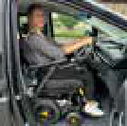  Hyundai Staria Drive From Wheelchair  Freedom Motors  The very first “Australian  Made” Hyundai Staria conversion with the feature to drive from your wheelchair and a lowered ﬂoor for wheelchair access. It is available inside entry access with an underbody lift for towing enthusiasts, or rear entry access with a ramp for ﬂexible parking options. Using remote controls, wheelchair users can independently enter the vehicle and transition into the driver’s position. The wheelchair can dock behind the steering wheel, allowing for self-drive via various control systems including push pull hand operated systems, driving controls with joystick or mini steering wheels, together with voice control that can be operated by your hands or your feet. | 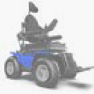  MAGIC XT4  Magic Mobility  Step up to driving the world’s most advanced 4×4 powerchair. The XT4 builds on Magic Mobility’s  unrivalled experience in delivering extreme oﬀ-road 4×4 powerchair performance by oﬀering even greater stability, range, comfort, and control than ever before. The XT4’s patented front and rear suspension, unique servo-powered steering and high-capacity batteries combine with the proven capabilities  of knobby, low-pressure tyres driven by unstoppable torque to make it the ultimate chair for outdoor adventurers.  - Unstoppable oﬀ-road traction.  - Superior patented suspension.  - Servo powered steering.  - Colour options and styling.  - Proudly Australian made.  - Splash resistant (not waterproof).
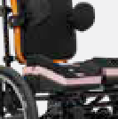  Constructa Cushion  Spex  The Constructa system is a range of modular  cushions which can adapt  to accommodate complex postural needs for all users. From simple seating requirements to the most challenging demands, the result is better seating which minimises pressure while maximising comfort.  It’s our most anatomically adaptable cushion ever – and the foundation for a safer, more comfortable experience for every user. The result is a cushion which gives clinicians the power to provide refined solutions quickly while maintaining the ability to adapt and evolve over time. | 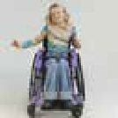  Kidevo Mini.t  Ottobock  The mini.t is a paediatric light weight tilt and space wheelchair that allows the user to still be  independent. The Mini.t wheelchair is individually adapted to the child and can be further adapted in size when needed.  It features a wide range of options and custom-made seating and back  support systems making the chair fit all sizes. Thanks to the adjustable centre of gravity, optimal driving behaviour  as well as an active and independent movement the child can be encouraged from early on (seat width starts at 16cm). It has a tilting of five degrees  to the front and forty degrees to the back all without changing the centre of gravity of the chair! This allows kids to still be active and independent whilst still having the options to tilt. | Q50R CARBON  Sunrise Medical  The Q50 R Carbon is your perfect travelling partner.  Weighing a mere 14.5 kg  (without batteries) and fabricated from premium carbon fibre, take a load oﬀ your mind (and your arms) knowing that this is an eﬀortless powerchair to lift. Foldable in seconds, it stores snugly away in the tightest of places too (and all without removing the battery).  Ready to go out? The Q50 R Carbon packs the robust, reliable QUICKIE performance to get you from A-B (or even A-Z, thanks to its extended 24 km range). And with 5 eye-catching accent colours, you’ll bring a touch of style wherever you go.

See over for second page of finalists...

Page 14

Finalists for Best New Product Award are:

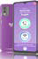  The SilverFox  BigPurplePhone  The SilverFox has popular features such as no  spam for people who are vulnerable, big text,  big buttons and only the Apps you really need. Simple contact lists make connecting to loved ones simpler while still providing essential smartphone features. Full screen notifications make voicemail and missed calls much easier.  Now we are finding our phone also suits people who are vision impaired, and people who have other cognitive decline or disability.  As we grow, we are looking for ways to make everyday communication simpler for more people. | 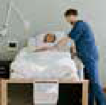  Tidewave Mattress  MediMart  Tidewave Mattress is a revolutionary moving mattress. By continuously  moving, it helps prevent and also heals pressure ulcers.  Several users’ feedback include undisturbed sleep, more energy during the day, no more need for opiates and so many more benefits.  It has been released to the Australian market just this year and was exhibited at ATSA Expo earlier this year. | 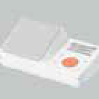  Voice™  Guardian Safety Pendants  Voice™ is the only stand-alone voice activated personal alarm  (PA) in Australia. The device is designed to be plugged into a standard electrical outlet within the home. A built-in back- up battery can power the device for 24+ hours allowing semi-portability.  - Intuitive key words -  Voice™ will call 000 when the user cries out ‘Emergency! Emergency!’  Voice™ will contact up to five people if ‘Call for help’ is uttered twice.  - Works even where there is no mobile phone coverage, and also outside the home wherever there is a cell signal.  - Contacts using the Voice™ App or push notifications to a computer.
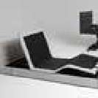  Sirius Adjustable Bed  Sleeptite  Sirius, an innovative, fully adjustable bed designed to unite clinical care with the  creature comforts and feeling of home. Well-engineered machinery and beautiful composition, the bed frame weaves clean aesthetics together with seamless functionalities. Sleeptite successfully developed a unique hidden castors system that will revolutionise the way  home care beds can be designed resulting in a high-low bed that meets the ﬂoor-line (<200mm) to OH&S height standard (>750mm) with a column-less and  stylish design that would be a welcome inclusion in any bedroom. The low height of 200mm at the top of the bed surface means injury can be significantly reduced or avoided in the event of a fall from bed. | 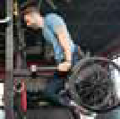  TiLite CR1  Permobil  Every single detail of the TiLite CR1 has been carefully designed to bring true innovation to  TiLite. From specially designed castor bearings for vertical load application and weight reduction, to new carbon fibre castor wheels and titanium reinforcement trim rings, this chair revolutionises the idea of a manual wheelchair from the ground up. With an aerodynamic tube profile and a foam- filled core, the CR1’s carbon fibre frame has been designed for uncompromising performance and strength. Custom- profiled side guards that act as structural members to the frame hold the backrest in place without hinges and allow you to fold down your backrest for easy transportation. | 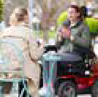  XT2 – Two Wheel Drive Electric Wheelchair  Magic Mobility  The XT2 is designed to  journey far and wide outdoors, to let you see and do more than ever before. Confident in the stability of a long wheelbase rear wheel drive with fully independent front and rear suspension. Powered by massive motors and long- range batteries, you can manoeuvre with ease thanks to the precision of servo- powered, joystick-controlled steering.  Enabled by personalised seating options and equipped with features and accessories designed for your outdoor journey.
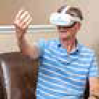  Ulysses® Upper Limb VR Therapy System  Neuromersiv  Ulysses®, developed by  Neuromersiv, represents a leap forward in upper-limb rehabilitation, combining immersive virtual reality (VR) with the precision of clinical design.  As a TGA-registered system, it’s not just about wearing a headset; it’s about engaging in task-specific rehabilitation that’s both enjoyable and tailored  to promote maximum engagement, compliance, and, most importantly, functional recovery. Designed for use in the earliest phase of neurological rehabilitation, Ulysses enhances therapy’s impact with a diverse array of tasks, focusing on everything from  motor skills to daily living activities, thus promising improved outcomes. | 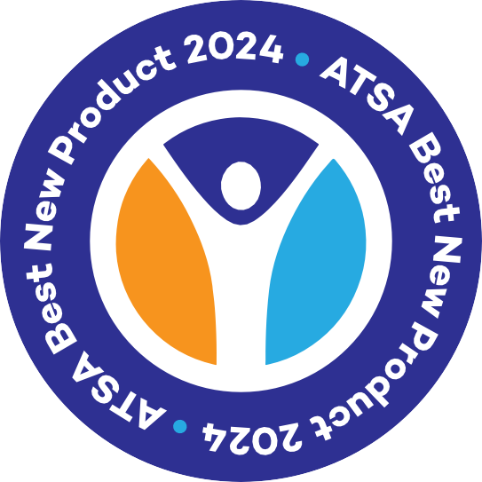  Scan here to VOTE  NOW!  Voting closes 4pm AEST 29 May 2024.

